

HOTEL CORPORATION OF INDIA LTD.,
IGI Airport, Terminal-2
New Delhi-110037.

Public Tender Notice

Public Tender No. | DEL/09 /2014-15, Dtd. 08.04.2014
Description | Public Tender For Flight Operations Services at Chefair Flight Catering, New Delhi. Estimated value : Rs. 1.85 crores per annum.
Last date/ time for Issue/ collection of Tender- 1200 hrs 15.5.2014
Date/ time for pre-bid conference for clarifications- 1100hrs 05.05.2014
Last date/ time for submission of Tender - 1500 Hrs on 15.05.2014
Date/ time for opening of Tender - 1500 Hrs on 15.05.2014

For further details regarding tender documents, please visit our website http://www.hci.in. Amendments (if any) shall be hosted only on HCIL website 07 days prior to opening of the tender and no separate intimation for amendment/extension shall be published in the newspapers.

s/d
Dy. Manager (Purchase)

HOTEL CORPORATION OF INDIA LTD.,
IGI Airport, Terminal-2
New Delhi‐110037.

Tender No. DEL/09/2014-15 , Dated: 08.4.2014 , Due on; 15.05.2014
Sub: Flight Operations Services at Chefair Flight Catering, New Delhi.

TENDER DETAILS

Sealed / closed tenders are invited by “Hotel Corporation of India Limited” herein after termed as “HCIL” from prospective bidders under two bid system that is Technical Bid : Part-A and Financial Bid : Part-B for the subject services. The prospective bidders fulfilling Technical eligibility criteria of this Tender may apply as per following documents : -

1.0 Tenderers are requested to submit their quotations as per following documents :

SN | Particulars | Annexure
1.1 | General Terms & Conditions | I
1.2 | Pre-qualification Criteria / Scope of work. | II
1.3 | Certificate for unconditional acceptance of Terms & Conditions of the tender. | III
1.4 | Technical Bid Form- Part A | IV
1.5 | Price Bid Form - Part B | V
1.6 | Estimated value : Rs. 1.85 cr. per annum.

2.0 Method of submission of Tenders / quotations in two bid system :
2.1 Envelope one - Shall contain duly filled “Technical Bid - Part A ’ together with EMD and supporting documents. The envelop should be superscribed with: ENVELOPE ONE – “Technical Bid- Part A” for “Tender No. DEL/09 /2014-15, Dtd. 08.04.2014, dated : 8.4.2014, Due Date: 15.05.2014. Name of the Tenderer / Co. and Tenderer,s address to be written at the bottom of envelope for identification.
  - Envelope two : Shall contain duly filled “Price Bid Form – Part B”.The envelop should be superscribed with ENVELOPE TWO - “Price Bid – Part B” Tender No. DEL/09 /2014-15, dated : 08.04.2014, Due Date: 15.5.2014. Name of the tenderer / Co. and Tenderer,s address to be written at the bottom of envelope for identification.
  - Envelope three (Master envelope) : The above two sealed / closed envelopes (Envelope One and Envelope Two) must be put in the “Third / Master Envelope” which should be superscribed with “Quotation for Tender No. DEL/09/2014-15, dated: 8.4.2014, Due Date: 15.05.2014. Name of the tenderer / Co. and Tenderer,s address to be written at the bottom of envelope for identification.

Note : The tenderer(s) may use “HCIL” Tender Documents for applying to this tender and must put their Co’s Stamp on each page duly signed by the Authorized signatory of the Tenderer / Co. For submission of Price Bid, Tenderer can use their Company letter head for submission of Bid but in this case, it has to be typed in the manner / format shown in our “Price Bid Form- Part B”.

Contd..2/-

Page ; 2

  - Submission of Tenders : The tenders should be submitted at the Corporate Purchase Tender Box, kept at Security Department, Centaur Hotel, IGI Airport, New Delhi-110037 on or before 1500 hrs. of 15.05.2014. No bids will be entertained after the stipulated time/ date.
  - The prospective bidders may send their offers in sealed/closed envelope through messenger or through courier services so as to reach us at above mentioned address on or before closing date/time of the Tender.
  - The tender closing date / time is 1500 hrs on 15.05.2014 . The closing date/time may be extended at the sole discretion of ‘HCIL’ and shall be uploaded on HCIL website only.
  - The amendment, if any, also including tender due date/time shall not be published in the News Papers and No separate intimation shall be sent in this regard to the bidders who had already applied.
  - The Technical Bids shall be opened on the due date /time of the tender.
  - Tenderers who wish to attend tender opening may do so OR send their representative with authorization letter on their Company’s letterhead duly signed by their authorized signatory which should be produced at the time of opening of tender at above address / time.

3.0 Pre-bid conference : A Pre-bid conference shall be held at Conference Room at Centaur Hotel,IGIA,Terminal-2, New Delhi-110037 at 1100 Hrs on 05.05.2014 with the representatives of the prospective bidders.
3.1 It may be noted that a maximum of two representatives of a bidder would be permitted only against an authorization letter from their authorized signatory to attend the pre-bid conference.
3.2 The clarifications, if any, provided prior to the Pre-bid conference, at the Pre-bid Conference and there after till the last date that is 15.05.2014 for seeking clarifications, will be published under “Tender” on the HCIL website www.centaurhotels.com in the last being on 15.05.2014. No individual clarifications will be sent to the tenderers.
3.3 Amendments (if any) shall be hosted only on HCIL website 07 days prior to opening of the tender and no separate intimation for amendment / extension date/time shall be published in the newspapers.

4.0 ‘HCIL’ reserves the right to reject any tender in part or full or annul the whole tender process without assigning any reason.

- The Commercial Bids of only technically suitable vendors will be opened thereafter.

Sd/
Dy. Manager (Corporate Purchase)

HOTEL CORPORATION OF INDIA LTD.
IGI Airport, Terminal 2, New Delhi‐110037.
Annexure:I

Tender No. DEL/09/2014-15/ ,Dated: 08.4.2014 , Due on; 15.05.2014

Sub: Flight Operations Services at Chefair Flight Catering, New Delhi.

General Terms and Conditions

1. ‘HCIL’ as used in the Tender document means “Hotel Corporation of India Ltd ”.

2. Contract means the Contract for providing Flight Operations Services at Chefair Flight Catering, New Delhi. Estimated Tender value : Rs. 1.85 Cr. per annum.

3. The “Successful Tenderer” or “Service Provider” as used in the Tender document, shall mean the one who has been declared as
i) Lowest bidder .
ii) Whose tender is under consideration for award of Letter of Intent (LOI)
iii) Received Letter of Intent (LOI).
iv) Awarded Contract for commencement / execution of services.

4. The “Tenderer/ Party ” as used in the Tender document, shall mean the one who has signed the tender form and submitted the quotation in response to our tender notice.

5. It is further clarified that any individual signing the tender or other documents in connection with the tender must certify whether he signs as:
i) A "Sole Proprietor" of the firm or constituted attorney of such sole proprietor.
ii) A partner of the firm, for partnership firm, must have authority to refer to arbitration, disputes concerning the business of the partnership by virtue of either the partnership agreement or a power of attorney. Alternately, all the Partners should sign the tender.
iii) Constituted attorney of the firm, if it is a Company.
iv) An authorized signatory of the firm.
v) A Karta of HUF in case the firm is constituted under HUF.

6. The Bids shall be evaluated / compared on the basis of details filled in the tender form and documents provided by the Bidder with the Tender form.

7. Offers should be valid for a period of 120 days for consideration of HCIL from the date of opening of the Bids.

8. Earnest Money Deposit (EMD) :
- The Tenderer will furnish along with their quotations EMD of Rs. 50,000.00 (Rupees Fifty Thousand only) in the form of DD/Pay Order drawn in favour of “Hotel Corporation of India” payable at New Delhi. Or may deposit cash at Cash Counter at Centaur Hotel / chefair Flight Kitchen, IGIA, New Delhi and must enclose receipt with the Tender form.
Contd. …2/-

Page: 2

Annexure:I

b) EMD in any other form shall not be accepted and if done so, the tender shall out-rightly be rejected.
c) Tenders received without EMD/ lesser amount of EMD will be rejected.
d) EMD so deposited shall not carry any interest.
e) In case of violation of terms of the tender, EMD shall be forfeited.
f) In case, the successful Tenderer refuses to accept the LOI/Contract or fails to abide by any terms of the Tender/fails to commence the work within stipulated time without valid reasons, EMD shall be forfeited.
g) In case of successful Tenderer, EMD can be adjusted in Security Deposit.
h) In case of unsuccessful Tenderers, EMD shall be refunded without interest, within a reasonable time after finalization of the Tender.
i) In case, the tenderer declines to accept or honor the contract awarded in his favor OR the Tenderer opts out of the tender process, for reasons unknown, after submitting their bid against this tender, EMD of such tenderer will be forfeited and the tenderer will not be allowed to participate in the next tender of HCIL .HCIL may also blacklist such tenderer for a period of 3 years. The decision of HCIL would be final in this regard.
j) Date of EMD DD/PO/Banker’s Cheque should be after the date of issue of Tender Enquiry.

9. Extension of Due Date:
i) The Due date /time of submission/ opening of Tender may be extended at any time, at the sole discretion of HCIL.
ii) Incase of any amendments/extensions and clarifications, issued to this Tender, the same will be hosted only on HCIL website : http://www.hci.in and HCIL will not issue any Press Advt or intimate the Tenderers individually of the same. The Tenderers are therefore advised to visit HCIL website regularly till the closing date of the Tender.
iii) In case, there is a change in Work-scope or Other Terms & Conditions of the Tender after publication of the NIT but before its due date, the last amendment, if any, will be hoisted a minimum of seven days before the closing date of the Tender. The vendors who have submitted their response before amendment shall have an option to re-submit their bids, before the new due date, if they choose to do so.
iv) In case, a revised bid is received before the due date, then only the revised bid will be considered and the original bid will not be opened.

10. Submission of Bids :
i) Tenderers are advised to study the tender documents carefully. Submission of tender shall be deemed to have been done after careful study and examination of the tender document with full understanding of its implications, nature and character of the work to be carried out, operating conditions and other pertinent matters which may affect the contract and / or the cost.
- Tenderers are required to fill up the tender in the prescribed forms only and must sign and stamp all the pages and all the papers attached with the Tender.
- Tenders be closed /sealed in an envelope and depositted in the designated Tender Box on or before due date/time.

Contd..3/-

Page;3
Annexure:I

iv) Bids should be unconditional. In case of any condition, the Bids shall be rejected.
v) In case during the evaluation, the documents / data submitted by the tenderer in support of the Tender are found to be at variance with documents, the bid of the tenderer would be out rightly rejected and would be disqualified and EMD would be forfeited.
vi) Rates quoted be clearly written / typed both in words and figures without any Overwriting. Overwriting, if any, should be counter signed by the Tenderer. In case of any discrepancy, the amount written in words shall be considered as final for the purpose of comparision of rates.
vii) Tenders not accompanying required information and documents are liable to be rejected out rightly. Any request for subsequent submission of any information/documents will not be entertained.
viii) Tender documents sent through Post or Courier will be at the risk of the Tenderer and HCIL will not be responsible for any loss or non-receipt of the Tender documents. Tenders received after due date/time will not be entertained/considered.

11. Undertakings:
a) The tenderer must agree that they shall provide required Services of at Delhi within 30 days from the date of acceptance of LOI (Letter of Intent).
b) The tenderer must agree that all the provisions of the contract Labour (Regulation & Abolition) Act 1970 and rules shall be complied with if the same are applicable to them. In case of successful tenderer, he shall obtain at his own cost and initiative license under the contract labour ( Regulation & Abolition) Act 1970 from the concerned authorities within 15 days of obtaining LOI / Contract for which necessary Form – V shall be furnished by HCIL.
c) Varifications of Licences / Registrations: The tenderer must agree that the registrations and licenses under all the applicable local and central taxes and laws and to be specified separately under each applicable Tax/Law/Act (i.e. Service Tax/Provident Fund Act/Income Tax Act/Shop & Establishment Act/ESI Act etc.) shall be produced for verification/checking of HCIL or to a third party authorized by HCIL / agencies of Govt. of India.
d) The tenderer must give an undertaking that the requisite work as per enclosed Work Scope (Annexure-II) would be executed to the satisfaction of HCIL .
e) The tenderer must give an undertaking that on the spot surprise checks could be conducted by HCIL / third party authorized by HCIL, anytime and shortcomings found, if any, shall be overcome within the given time or if not corrected the same shall be penalized by HCIL as per penalty clause.

12. The qualification of Tenderer and award of work would be subject to compliance of the eligibility criteria & undertakings as specified in the Tender and the LOI / contract would be withdrawn, if these requirements are not fulfilled.

13. Tenderers shall give the official mailing Address and Fax Numbers to which all correspondences shall be sent by HCIL. Also if address is changed in due course, the same shall be intimated to HCIL immediately.

Contd..4/-

Page;4
Annexure:I

14. HCIL reserves the right to accept or reject any/or all bids, annul the Tender process and reject any or all the bids at any time prior to the award of Contract without incurring any liability to the affected Bidder(s) / Tenderer(s) or without any obligation to inform the affected Bidder(s)/Tenderer (s) on the grounds of such annulment / rejection.

15. Any notice by one Party to the other pursuant to the Contract, shall be sent in writing to the address specified for that purpose in the Contract.

16. The Tenderer/Bidder shall not sub-Contract this Work or any part thereof to any other person, concern, firm or company without prior approval of HCIL.

17. Claims for damages
- HCIL shall promptly notify the Tenderer of any claims / deficiency on the part of the Tenderer arising under/out of the Contract.
- In case the Tenderer, having been notified, fails to take remedial action within the stipulated time as advised by HCIL official, it may take a remedial action without any further notice, at the Tenderer’s risk & cost. In this case HCIL may terminate the Contract without prejudice to any other rights, which v may have on the Tenderer under the service Contract.

18. Payment of monthly wages to the staff deployed :-
- The Tenderer shall pay wages for the previous month to his employee so deployed
for the Work, not later than 7th of following calendar month.
b) “HCIL ” shall not be responsible for payment of wages and or any other emoluments to the staff deployed and it shall be the sole responsibility of the Tenderer to make payment to the said workers in time and the Tenderer shall at all time keep “HCIL” indemnified against any such claims from its workers in this regard.
c) All records, documents under various statutory provisions including ESI / PF / Disbursement of monthly Wages etc. shall be maintained by the Tenderer and shall be open for inspection of an authorized representative of HCIL / third party authorized by HCIL and or Government Agencies.
19. Rates & validity of contract :
a) Validity of contract : Contract will be valid for a period of one year and extendable for further period of one year on mutually agreed terms depending upon satisfactory performance of the party. However, HCIL, can extend the contract for 03 months at same rates terms and conditions.
b) The validity of Agreement comes to an end IPSO FACTO by efflux of time unless or otherwise renewed / terminated.
- Rates agreed to in the Contract shall remain firm for contract period and no request for further price escalation on any ground shall be entertained during the Contract period including extensions, if any, except for increase in the minimum wages as increased by the Govt. of NCT of Delhi. However, no increase shall be applicable up to + 10% increase in the minimum wages as on date of application of the Tender.

Contd..5/-

Page; 5

Annexure:I
d) Inclusions:
The rates quoted in the tender shall be inclusive of Government Taxes and levies, Capital Cost, cost of equipments, Manpower,cost of raw material / cleaning agents and detergents, Airport Entry permit fee, Dial training cost, Provision for Name Badges & Uniform including High visibility jackets, ID Cards and all statutory payments like ESI / PF etc.
e) Exclusions:
i) The Service Tax (including education cess) , if applicable on these services, shall be excluded. Service Tax, if applicable, would be paid / reimbursed separately as per prevailing rates,on submission of receipt as proof for payment together with monthly bills.
ii) DIAL charges, if any, shall be excluded from the above quoted rates. Any additional charges /levies imposed by DIAL would be re-imbursed separately
by HCIL on production of receipt as proof of payment.

20. Rates quoted in the Tender shall be valid for 120 days from the date of opening of technical bids for consideration of HCIL.

21. Price negotiation :
It is not the general practice of HCIL to carry out price negotiations following opening / evaluation of the bids, the Tenderers are therefore advised in their own interest to submit their best quotes in response to this Tender. HCIL, however, reserves the right to carry out negotiations in exceptional cases with the L-1 Tenderer, if required.

22. Award of contract / LOI , acceptance, commencement/execution & validity:
The award of Contract / LOI shall be subject to fulfillment (in addition to eligibility criteria and the Undertakings) and acceptance of the terms & conditions of the tender by the Service Provider : -
i) The Tenderer has to convey acceptance of LOI (Letter Of Intent) within 7 days of receipt of LOI.
ii) The successful Tenderer has to submit the security deposit of 5% of one year contract value in the form of Demand Draft / Pay order / Bank Guarantee from a scheduled Bank at the time of commencement of the job but positively before submission of 1st Bill.
iii) The successful Tenderer, on receipt and acceptance of the LOI, has to execute an agreement of terms & conditions of the contract on Rs.100/- non-judicial Stamp Paper with ‘HCIL’ within 30 days of commencement of services.
iv) The successful Tenderer should commence the services within 30 days or as specified in the LOI from the date of the acceptance of LOI.
v) In case, the successful tenderer is unable to commence the services within 30 days from the date of acceptance of LOI, he shall intimate ‘HCIL’ for the reasons for the same.
- In case, the reasons for delay of commencement of the services are not convincing, ‘HCIL shall have a right to cancel the LOI / Contract and shall be free to make alternate arrangement and the EMD of such service provider shall be forfeited. Besides this, the successful tenderer will not be considered for next tender. HCIL may black list such tenderer for a minimum period of 3 years. The decision of HCIL would be final in this regard.
Contd..6/-

Page; 6

Annexure:I

23. Acts and behaviour of deployed staff :
a) The Service Provider shall be solely responsible for the acts and deeds of his personnel deployed by him for the services. ‘HCIL’ will, in no way, be responsible for violation of any rules/regulations/instructions of the concerned agencies and/or for any loss or damage caused by his personnel to ‘HCIL’ Staff and/or third party and any such loss or damage shall have to be compensated/borne by the service provider.
b) Supervision of personnel & equipments provided by the Service Provider shall be his responsibility.
c) Verification of antecedents of service provider’s personnel will be his responsibility.
d) The service provider will provide Name Badges, Identity card, Uniform / High visibility jackets (if applicable) etc to his personnel at his own cost. He will also ensure that the persons wear the uniform and keep it neat, clean and tidy.
e) The Service provider shall ensure the quality of services which are performed by its personnel and in case of any complaint against a particular person; the Service provider shall have to replace such personnel failing which, “HCIL”, shall have right to refuse entry of any such personnel.
f) In case of operational exigencies, the Service provider shall provide additional manpower /equipment to perform the Work as defined in the Work-Scope and to maintain quality of Work to the satisfaction of HCIL.

24. Exit clause / termination of the contract/agreement : The Contract may be terminated under the following circumstances :
- HCIL may at any time terminate the Contract with immediate effect by giving written notice to the Tenderer/ Bidder, if Bidder becomes bankrupt or otherwise insolvent, provided that such termination will not prejudice or affect any right of action or remedy which has accrued or will accrue thereafter to “HCIL”. In this case no compensation shall be made available to the Bidder/Tenderer.
- In case of unsatisfactory performance or breach of any of the clauses of this Contract, HCIL shall issue a notice of 30 days to the party to rectify the breach and improve the performance failing which HCIL shall be at liberty to terminate the Contract/Agreement by providing a 30 days written notice to the party. The Tenderer/Bidder shall not have any right to dispute or question the judgment of ‘HCIL” on its unsatisfactory performance.
- Change of circumstances/operations: In case of change in situation/circumstances, etc. “HCIL” shall have the right to terminate the Contract by serving a 90 days written notice to the Tenderer / Bidder. In this case, the Tenderer / Bidder shall not have any right to claim damages compensation from “HCIL”
- The successful Tenderer shall also be at liberty to terminate the Contract by providing to HCIL Limited a 30 days written notice.
- On termination of the Contract Tenderer / Service Provider / Bidder shall handover all the documents related to the services rendered and all equipments, fittings including Furniture, Fixtures and all items that have been issued to Tenderer / Service Provider and all the Money due & payable to HCIL with complete accounting details for the same.

Contd..7/

Page: 7
Annexure: I
25. Rejection of bids :
The response to the Tender will be liable for rejection on the following grounds:
i) If the Tender has been received after due date and time of the Tender.
ii) In case tenders are received at address other than as mentioned in the documents.
iii) If the bids have been received unsigned or are incomplete.
iv) If the Tenders are received by fax or email.
v) If the Tenders has been received without EMD or the EMD has been submitted in a mode other than as specified at Clasue 8 above.
vi) If the Tender is submitted in the different name.
vii) Ineligible bids shall not be entertained and the decision of HCIL in this regard would be final. No correspondence in the regard will be entertained.
viii) If tenders received are conditional.
ix) If tenders are not filled in the prescribed format.

26. Queries from the tenderers during Evaluation of Bids:
No queries shall be entertained from the Tenderers during evaluation process of bids.
27. Security Deposit:
a) The successful Tenderer, on award of LOI/ Contract, shall deposit, and continue to maintain for the entire period of agreement plus three months, a sum equivalent to 5% of Annual value of Contract as estimated by HCIL, as Security Deposit in the form of Demand Draft / Pay Order/ Bank Guarantee from a Scheduled Bank. In exceptional cases depending upon merits , ‘HCIL’ would reserve the right to deduct the amount of ‘SD’ from any outstanding invoices of the vendor irrespective of the PO against which the ‘SD’ may be due.
b) The Security Deposit has to be deposited at the time of commencement of the Work but positively before submission of 1st Bill.
c) In case, Security Deposit is not deposited in time, the bills shall not be processed for payment.
d) In case of breach of Contract or violation of any terms of the Contract the Security Deposit shall be forfeited.
e) security deposit shall not bear any interest, and shall be refunded without
interest only on successful completion of the awarded work and on fulfilling of all Contractual obligations.

28. Payment of bills:
- The Tenderer shall maintain a shift wise Log Book for attendance of deployed personnel / supervisors for controls. HCIL will have the right to pursue these details for verification of bills submitted by the service provider.
- The service provider has to submit consolidated monthly bills to Sr. Mgr –
Kitchen / user Dept. CFCD for certification and forwarding of same to Dy.Mgr.(F) for payment.
iii) HCIL will make payment on monthly basis by an account payee cheque within 30 days
of the submission of Bills for the undisputed amount.
iv) No advance payment shall be admissible in any case.
v) Necessary deductions at source towards applicable income tax shall be done as per Govt rules as applicable from time to time.
Contd. 8/-

Page: 8

Annexure:I
29. Indemnification:
a) The Tenderer/Service Provider shall indemnify HCILagainst any claims,
damages, loss or penalty including costs thereof in case of liability arising out of any accident/incident/theft involving manpower deployed by him/it.
b) HCIL will not be responsible for any injury sustained by Tenderer’s/Service
Provider’s personnel during the performance of its/their duties and also any damage or compensation due to any dispute between them and it’s personnel. Any expenditure incurred by HCIL to handle the situation arising out of the conduct of personnel deployed by the Tenderer/Service Provider will be made good from Security Deposit/Bills of the Tenderer/Service Provider.
- Compliance of Labour Laws / Statutory Obligations:
The Tenderer/Service Provider shall also indemnify HCIL against any acts, laws, rules and/or regulations (including Labour Laws) and amendments enacted from time to time thereto by any Central/State/Local or Municipal Authorities as also which may be applicable to the Service Provider/Tenderer.
d) The Tenderer shall indemnify HCIL against payment of penalty /third Party
claims/damages / loss of property of HCIL, DIAL, Any other party / penalty due to mishandling on the part of personnel provided by the Tenderer. The tenderer shall also indemnify for any liability arising out of any accident / incident involving his vehicles and shall reimburse any loss or damage to HCIL concerned party. In case, any such amount is not deposited / paid to HCIL , the same shall be deducted from his monthly Bills / Security Deposit / Future payments due to the Tenderer.
e) The Tenderer shall also indemnify to reimburse any loss or damage by his personnel to HCIL personnel or property including machinery, equipment or buildings. In case, any such amount is not deposited/paid to HCIL, the same shall be deducted from Security Deposit/Bills/Future payments due to the Tenderer/Service Provider.

30. Compliance with statutory provisions :
a) The Tenderer shall be responsible for ensuring compliance with provisions of related Labour Laws (Central/State/Municipal/Local) and particularly with regard to Minimum Wages Act, Payment of Wages Act, PF Act, ESI Act, Payment of Bonus Act, Contract Labour (R&A) Act, Bombay Labor Welfare Act, Workmen Compensation Act etc and amendments there to as applicable from time to time.
b) The Tenderer shall be solely responsible for any cost and consequences on account of any breach and/or non-compliance of any of the provisions of the Labour Laws. The Tenderer shall indemnify HCIL against any claims/costs/damages and penalties in respect of breach of any of the provisions of the laws in force.
- The employees of the Tenderer/Contractor shall not be deemed to be employees of HCIL, hence the compliance of the Laws with respect to its/their employee/their welfare will be the sole responsibility of the Tenderer/ Contractor.
- HCIL does not bind itself to provide any Canteen, Medical & Transport facilities to the employee of the Tenderer/Contractor.
- It shall be the responsibility of Tenderer/Contractor to comply with all liabilities arising out of any provisions of Labour Acts/Enactments hitherto in force or enacted from time to time during the execution of this agreement.
Contd. 9/-

Page: 9

Annexure:I

f) The Tenderer / Contractor has to ensure that the disbursement of wages to his employees will be made on or before 7th of the following month and also to ensure that the prescribed minimum wages are paid for the applicable category of his employees and a record be maintained.

31. Compliance of Security Regulations:
  - The Tenderer must note that Centaur Hotel and Centaur Flight Kitchen are located in the periphery of IGI Airport, New Delhi and Airport security is under the control of DIAL/GMR/BCAS. In case, Govt of India decides Centaur Hotel and Flight Kitchen have to follow security regulations of DIAL/GMR/BCAS, in that case service provider shall have to comply such security rules without any extra cost to HCIL.
  - Any violation of security regulations and indulging in illegal activities by his personnel will be at the cost / risk of the Tenderer / Service Provider.
c. The Tenderer / Service Provider should ensure verification of character and antecedents of his personnel by Police before deployment, since HCIL is “protected industry”.
d. The personnel so deployed must be in possession of photo identity cards provided by the tenderers under his signatures, company’s name and seal to be shown when demanded by HCIL officials.
- The Tenderer should have a system to surrender the I Cards of retired / terminated employees to avoid misuse.
- The Tenderer/Service Provider shall take responsibility for good conduct of its employee in HCIL premises. If any of its employee is involved in any theft/pilferage of property of HCIL Passenger/ Passenger Baggage/ HCIL property , HCIL reserves the right to impose penalty on the Contractor apart from initiating legal action .
- It will be the responsibility of the Tenderer/Service Provider to ensure that no unauthorized personnel other than those deployed specifically for the Work gains access to the premises where the services are to be provided.

32. Interpretation :
In the event of any difference in the interpretation of any of the clauses of the Service Contract / Agreement and/or the Tender documents, the clarification given by HCIL shall be final and binding.

33. Relationship:
The relationship shall be on ‘Principal to Principal Basis’. Nothing contained shall be construed or interpreted as constituting a partnership agency or joint venture or any association between the parties. Neither party shall have any right, power or authority to enter into any agreement or act in any manner on behalf of the other.

34. Arbitration :
Subsequent to award of contract against this Tender , any dispute or differences, whatsoever arising between the parties out of or relating to the construction, interpretation, application, meaning, scope, operation or effect of the Contract / Service Agreement or validity or the breach thereof, which despite best efforts cannot be amicably settled between the parties shall be referred to “Scope Forum of Conciliation and Arbitration – Govt of India”and the award made in pursuance thereof shall be binding on the parties to the arbitration.
Contd. 10/-

Page: 10

Annexure:I

38. Jurisdiction :
The construction, interpretation, validity and performance of such Contract/Agreement shall be governed by the laws of land of India. Any disputes arising out of implementation of the Contract between HCIL and Service Provider whatsoever shall be subject to the Jurisdiction of New Delhi / Delhi Courts Only.

***********

HOTEL CORPORATION OF INDIA LTD.,
IGI Airport, Terminal 2, New Delhi‐110037.

Annexure:II

Tender No. DEL/09/2014-15/ ,Dated: 08.4.2014 , Due on; 15.05.2014

Sub: Flight Operations Services at Chefair Flight Catering, New Delhi.

Eligibility Criteria for bidders , staff to be deployed, Scope of Work & Penalties

1.0 Eligibility Criteria for bidders
The prospective bidders / tenderers fulfilling the following pre-qualification criteria as on date of application of the tender may apply in the prescribed format :
  - The tenderer must be Principle service provider having experience of three years in providing Housekeeping Services . A list of clienteles together with the order copies, performance certificate from the user to be enclosed in support of experience.
  - The tenderer must have PAN /GIR No., WCT/TIN No and Service TAX Regn Nos Self Certified copy of each to be enclosed.
  - The tenderer must have an average annual turnover of Rs. 15.00 Lacs per year for last three Financial Yrs. – i.e. 2010-11, 11-12 & 12-13 .Self Certified copy of ITR , Balance Sheet, Profit and loss account duly verified by Regd. Chartered Accountant to be enclosed in support.
  - The tenderer must furnish EMD of Rs. 50,000/- by way of DD/Pay Order / Cash Receipt. DD/ Pay order has to be in favour of Hotel Corporation of India Ltd and Payable at New Delhi. In case, EMD is paid in cash, it must be paid to HCIL, New Delhi before submission of tender and original receipt to be enclosed with the tender.
  - The tenderer must enclose self certified copies of all necessary documents with the Technical Bid Form-Part A.
  - The tenderer must have BCAS clearance/ clearance number for working inside Airport.
  - The tenderer must also enclose signed copy of certificate of unconditional acceptance of General Terms & Conditions, work scope along with the Tech.Bid Form –Part A,
  - Copy of documentary proof as required above must be furnished along with technical bid and replies such as “Applied for “or “under process” shall not be acceptable. In such cases and in case of not furnishing required information and documents with the technical bid, the tender shall be rejected.

2. 0 Eligibility Criteria for the staff to be deployed ;
- Minimum qualification of the staff deputed should match with respective designation required for Flight Catering Industry.
ii) The staff provided should have the approval of In-charge, Chefair Flight Catering, Delhi.
- All the staff should be medically cleared for working in a food industry by Government Hospital.
- The character and antecedents should be verified by the Police Authorities.
- The staff deployed should be of right age as per the Government guidelines.
- Staff provided should be prompt, punctual, efficient, presentable and courteous.
Contd…2/-

Page: 2

Annexure:II

3.0
SN | Activity | Morning shift | A/N shift | N/Shift | Total
1. | Loading & off loading catering on /of aircraft inside airport. | 08 | 06 | 04 | 18
2. | Offloading from Hi lift, sorting and dishwashing at CFCD. | 04 | 04 | 02 | 10
3. | Presetting of trays, assembly of flight items, loading in the hi lift. | 08 | 06 | 04 | 18
 | Total | 20 | 16 | 10 | 46

Note : 1. The above manpower is calculated based on workload of 8 double sector flights or 16 single sector flights.
  - The number of flights may increase/decrease depending upon operational requirement of Air India and allocation of work to CFCD.
  - The manpower is calculated for the sake of convenience of the service provider /tenderer for calculation of financial involvement on account of manpower. However, the contract will be purely a service contract not a manpower contract.

Scope of work /Definitions :
Chefair Flight Catering, Delhi in the business of In-flight Catering Services i.e. to supply meals on the Flights of the airlines. The service provider would be required to provide the following services at Chefair Flight Catering, Delhi located at Centaur Hotel Premises, IGI Airport, New Delhi-110037 on round the clock basis.

Presetting of Food Trays – assembly of flight items – loading in the hilift;

Loading and Offloading on/from aircrafts (Tarmac activities) and

Offloading from the hilift, sorting and dish washing,

All the above three activities will be known as Flight Operations throughout the document.

Contd…3/-

Page: 3
Annexure:II

Brief on flight catering :

- A flight-catering unit basically supplies food on the aircrafts strictly as per the requirements of the airlines. The food is preset on the equipment given by the airlines like trays, salad bowls, tinfoil dishes etc. These trays etc are then put in Food carts / trolleys or oven cages etc and these trolleys etc are loaded on the aircraft at their specified locations. Used / soiled trolleys etc are simultaneously offloaded and brought back to the unit. This equipment is loaded / offloaded through a high loader truck also known as hilift. Dirty / Soiled equipment is brought back to the unit, sorted, washed, wiped, stacked and prepared for further use on next flights.

- Food is prepared in the kitchen and laid in the equipment given to them by the Flight Operations. Preparation of food in all the departments of kitchen is out of the purview of Flight Operations.

- At present Chefair Flight Catering is catering to Air India domestic flights (narrow body). There are different types of aircrafts, which Air India is operating for its domestic sectors. Following are some of such aircrafts:

- Airbus A321
- Airbus A320
- Airbus A319

- On an average, all the aircrafts have a seating capacity of 170 passengers approximately. Some of the aircrafts have club class or J/Class and Economy class whereas some of the aircrafts have only economy class. The equipment used for J/Class passengers are porcelain whereas equipment used for economy class is melamine.

- With a seating capacity of 170 passengers, the food uplift will be 170 meals for passengers and 8 for the crew members per flight per sector.

- Some of the flights catered by the unit may also uplift food for two sectors i.e. 170 (plus Crew) meals for first sector ex Delhi and another 170 (plus Crew) meals for onward/return sector.

Contd…4/-

Page: 4
Annexure:II

- There are different types of uplifts depending upon the time of departure of the flights. Following are some of the types of uplifts:

- Breakfast
- Hi-tea
- Lunch
- Afternoon tea
- Dinner
- Supper
- Hot Snacks

- The menus uplifted on these flights are given by the airlines. Sample menus are attached as annexure.

9. Equipments :
There are two type of equipment used in in-flight catering .
a) Major equipments : Major equipments consists of Meal trolleys, half trolleys, Cabinets, Drawers, oven cages, beverage flasks etc.
- Minor equipments : Minor equipments consists of following :

i) Meal Trays – cosists of
    - Large trays
    - 2/3 trays
    - Snack trays
ii) Porcelain Items – consists of
    - Teacups
    - Saucers
    - Bread Plates
    - Large Plates
    - Side Plates
    - Salad Bowls
    - Casserole dish

iii) Butter Dishes

- Glass Tumblers / cutlery &crockery items
    - Large glass
    - Juice / Small glass
    - Wine glass

Contd…5/-

Page: 5
Annexure:II

- Cutlery Items
    - Teaspoons
    - Knives
    - Forks
    - Dessert Spoons
- Melamine items
    - Teacups
    - Salad Bowls
    - Side Plates
- Stainless Steel Items (SS)
    - Coffee pots
    - Teapots
    - Milk Pots
    - Sugar Bowls
    - Servers
    - Entrée Frames
    - Ice Buckets
    - Tongs

10 : Tray setup
Depending upon the type of uplift and the menu, an economy class/ J class meal tray may consist of the following :

- Breakfast set up
  - 01 Tray
  - 01 Teacup
  - 01 Cutlery set consisting of 01 teaspoon, 01 knife, 01 fork, 01 dessert spoon, 01 paper napkin, 01 toothpick, 01 sugar sachet, 01 milk sachet, 01 salt pepper sachet, 01 caterer’s card and 01 freshener.
- 01 Salad Bowl (for fruit compote)
- 01 Water Bottle
- 01 Bread Roll
- 01 Butter tub
- 01 Jam Sachet
- 01 Tomato sauce/Chutney
- 01 Shopping card
Note : On a flight load of 100 passengers and Breakfast uplift, there will be a total of 100 tray setups as per the Breakfast above.

Contd…6/-

Page: 6
Annexure:II

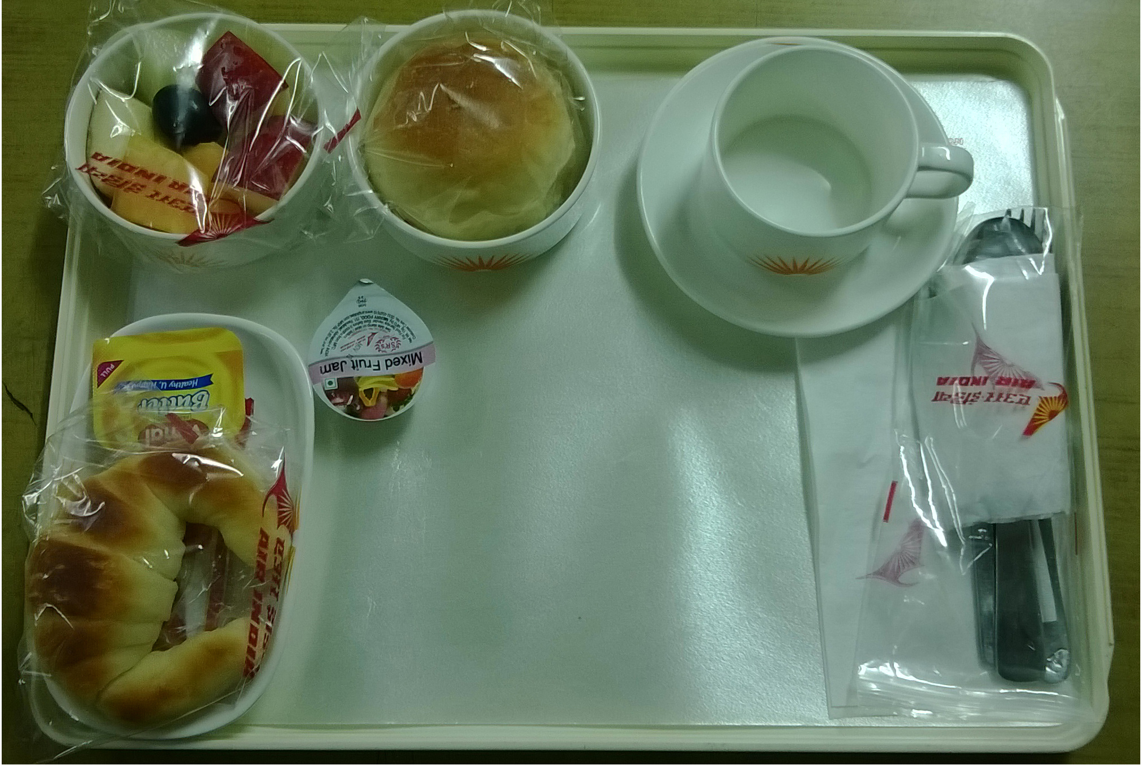 ← J/Class B/Fast

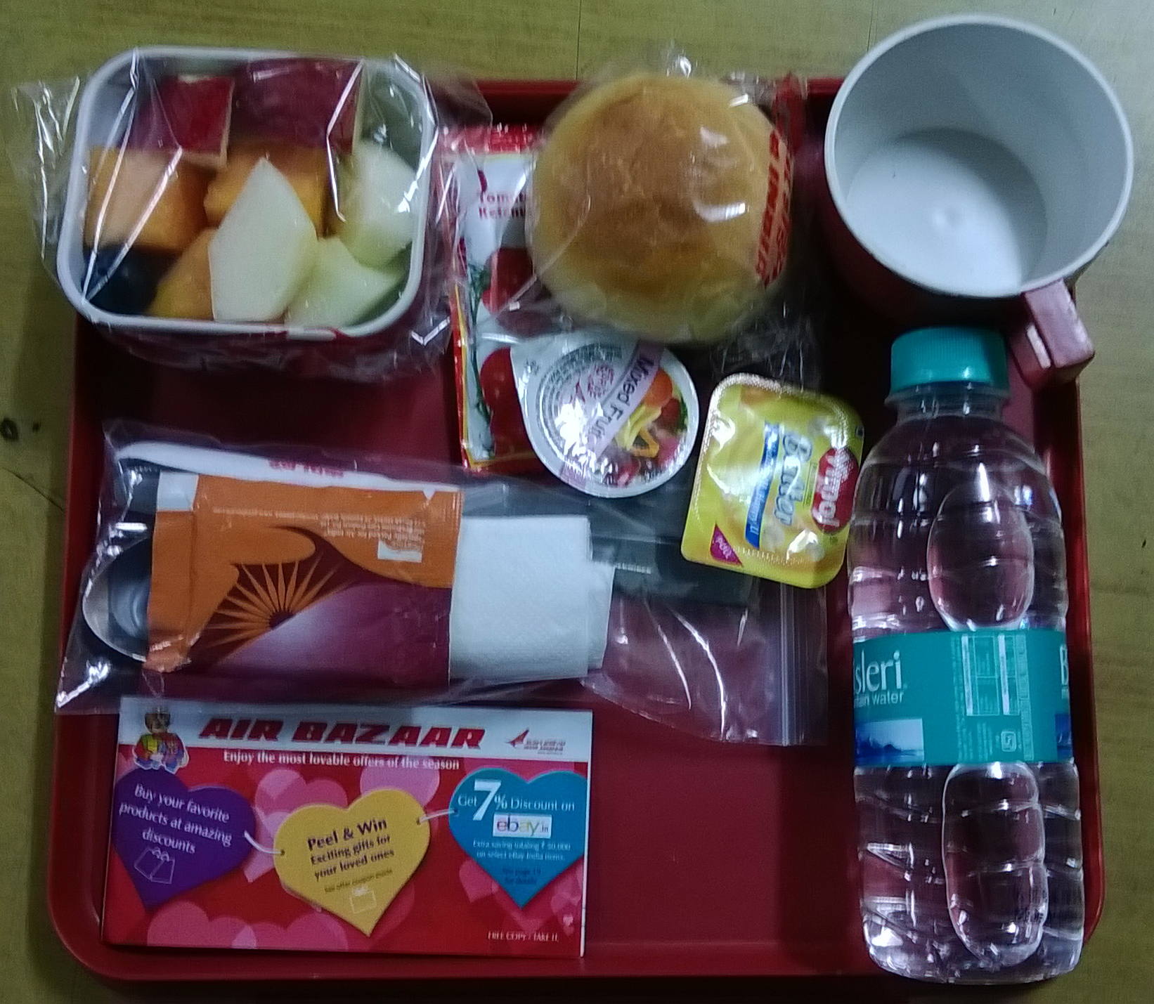← Economy Class B/Fast

- Lunch / Dinner set up

- 01 Tray
- 01 Teacup
- 01 Cutlery set consisting of 01 teaspoon, 01 knife, 01 fork, 01 dessert spoon, 01 paper napkin, 01 toothpick, 01 sugar sachet, 01 milk sachet, 01 salt pepper sachet, 01 caterer’s card and 01 freshener
- 02 Salad Bowls (for Salad and sweet dish)
- 01 Water Bottle
- 01 Bread Roll
- 01 Butter tub
- 01 Shopping card

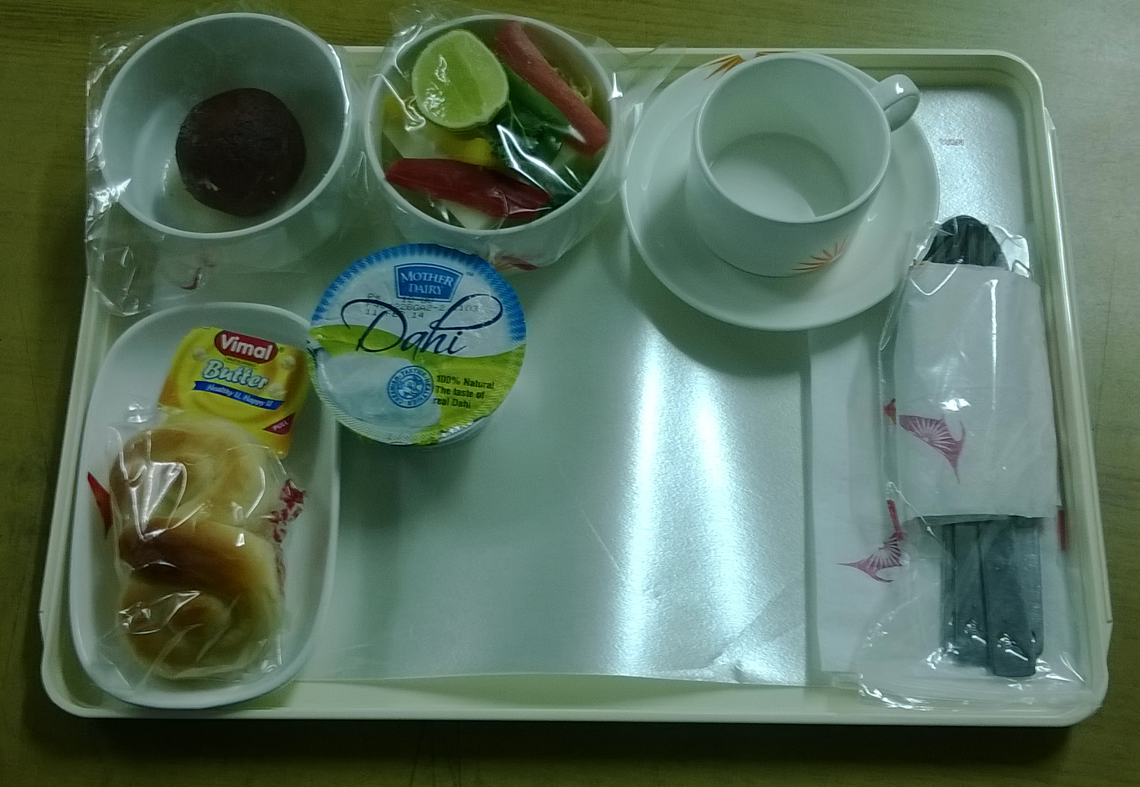 ← J/Class Lunch/Dinner
Contd…7/-

Page: 7
Annexure:II

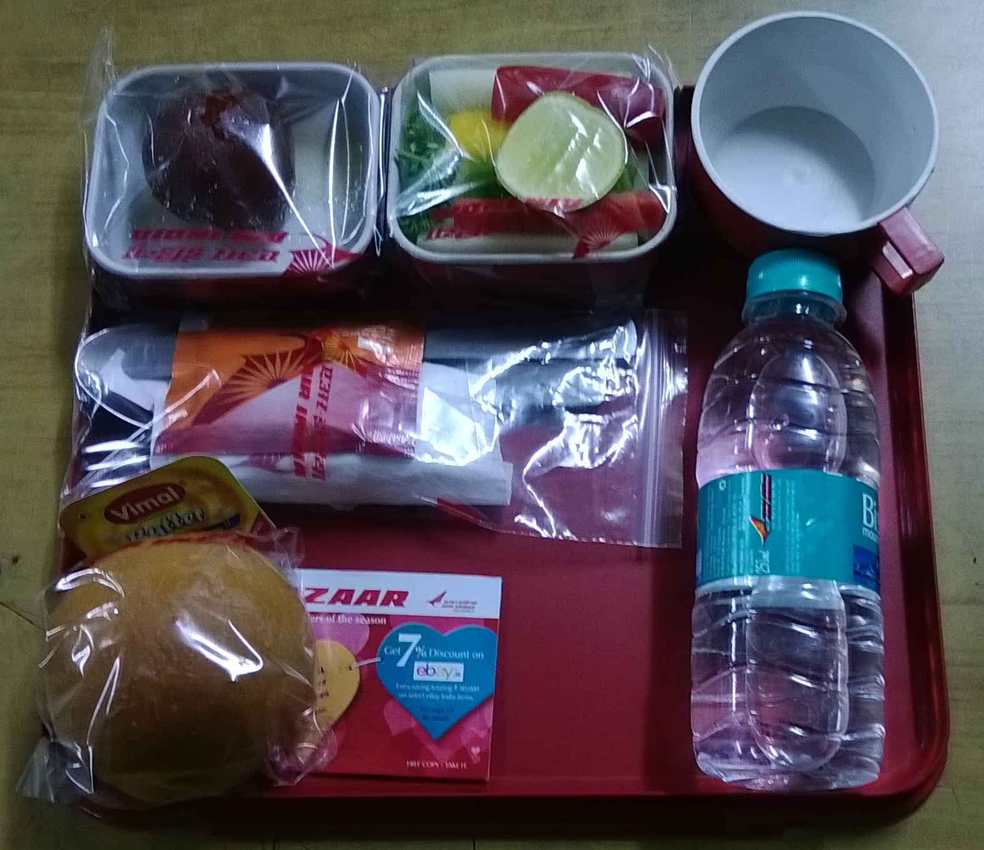← Economy Class Lunch/Dinner

- High Tea set up

- 01 Tray
- 01 Teacup
- 01 Cutlery set consisting of 01 teaspoon, 01 knife, 01 fork, 01 dessert spoon, 01 paper napkin, 01 toothpick, 01 sugar sachet, 01 milk sachet, 01 salt pepper sachet, 01 caterer’s card and 01 freshener
- 01 Salad Bowls (sweet dish)
- 01 Water Bottle
- 01 Sandwich duly cello wrapped
- 01 Tomato Sauce
- 01 Shopping card

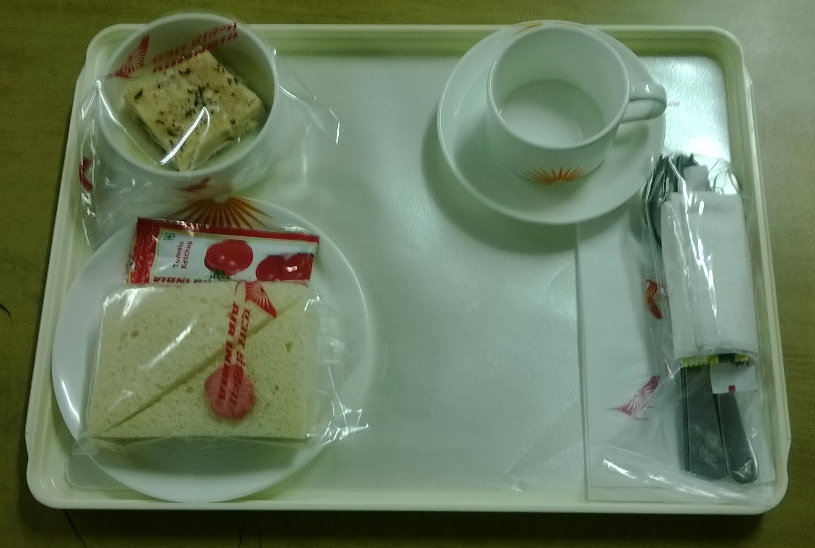← J/Class High Tea

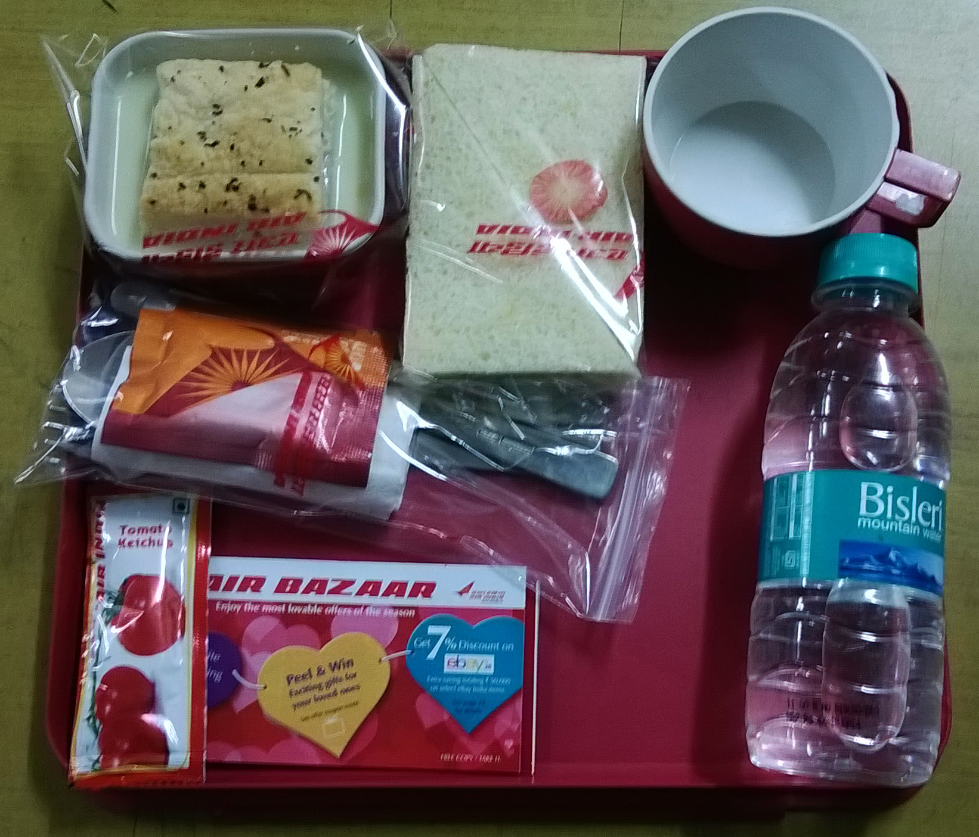← Economy Class High Tea

Contd…8/-

Page: 8
Annexure:II

    - In addition to the above economy class presetting, there will be J/Class preset trays also for the passengers depending upon the type of aircraft.

    - Typically on an A321 aircraft with 20 J -Class, 152- Economy Class seats and 8 Crew members, following will be the approximate number of equipments :

Equipments | Single sector uplift on full load | Double sector uplift on full load,
Minor Equipments | 20 J/Class tray setups,single sector crew meals as per menu | 20 x 2= 40 J/Class tray setups (plus double sector crew meals) as per menu
 | 152 economy tray setups as per above as per menu | 152 x 2=304 economy tray setups as per above as per menu
 | Dry Store items including water bottle cases, tetra pack juices, teabags etc. - all packed in bulk in bags and in drawers | Dry Store items including water bottle cases, tetra pack juices, teabags etc. - all packed in bulk in bags and in drawers
Major Equipments | 6-7 Meal Trolleys, 5 oven Cages, 14 SS service equipment items | 13 Meal Trolleys, 6 oven Cages, 14 SS service equipment items

Note (i): All minor equipments are put in major equipments (meal trolleys or half trolleys) as per the galley-loading plan for the aircraft.
(ii) All major equipments that is 13 meal trolleys, 6 oven cages and SS items will be loaded in the hi-lift for loading on to the aircraft.

    - Following the flow chart of the activities involved in the unit:

Loading/Offloading on / from flights (Aircrafts) - Tarmac activity (a)

Offloading of soiled equipment in the Dish Washing Area (b)

Equipment
Dish Wash
&
Stacking (c)
Log

Contd…9/-

Page: 9
Annexure:II

Preparation of equipment including cutlery packing and glass (d)

Presetting of food -TrayAssembly
(e)
Log

Production
&
Meal
Packing

Preloading Chilling (f)

Preloading flight Assembly, Checking
&
Security Check (h)
Airline Stores

Bond (g)
Chilling of Meals

Loading in the hilift (i)

To the Aircraft (a)

    - Activities involved

- Loading/Offloading on / from flights/aircrafts – Tarmac activities

- With meal trolleys and other equipment as described above, the hilift is released from the unit for loading on the flights/aircrafts at the designated aircraft parking bay which is informed by the airline staff prior to releasing of the hilift from the unit. As per present airline norms the hilift has to be at the tarmac 1½ hour prior to the departure of the flight.
- On the arrival of the aircraft the hilift is aligned first at the front door and then, after loading and offloading of catering equipment from front galley, the hilift is aligned at the rear door for loading offloading from the rear galley. Aircraft doors are opened/closed only by the airline staff and not by caterers’ staff.

Contd…10/-

Page: 10
Annexure:II

- In the aircraft the fresh equipment and the meals are loaded at the specified locations after offloading of the soiled equipment in to the hilift. The galley tabletops are cleaned by the caterers’ staff. After handing over of meals to the cabin crew the hilift is removed from the aircraft and parked at the designated area on the tarmac. No equipment is washed in the hilift.
- There are instances where the off loadings are exchanged with other caterers and unused dry store items are handed over to Air India Catering section. In the event of exchange of equipment with other caterer, the hilifts of both the caterers are positioned back to back and the equipment is exchanged.
- Samples of the meals are shown to Air India catering officers before loading on the aircraft.
- After the aircraft move out the delivery challan is got signed from the AI Catering Supervisor and Catering Officer.
- After all the above activities, the hilift is brought back to the unit and aligned at the offloading platform at the unit.

- Offloading of soiled equipment in the Dish Washing Area
- Immediate on arrival of the hilift, entire soiled equipment is offloaded into the sorting area and major items’ inventory is taken.
- Security checks the items received and takes major inventory.

- Equipment Dish Washing & Stacking
- The soiled equipment is sorted out and segregated in different sinks and are washed thoroughly either through three-sink method or through dish washing machine. The existing flight type dish washing machine is not fully automatic.
- The garbage generated on the trays like soiled/dirty paper napkins, wrappers, foil dishes/covers etc is thrown in the dustbins/garbage bins.
- Garbage disposal is third parties responsibility.
- Retrievable dry store items like water bottles, soft drinks etc are handed over to airline stores.
- All major equipment are also washed thoroughly and dried/wiped. All stickers etc are also removed.
- The washed equipment is dried and wiped immediately after washing and stacked in baskets/racks. These items are ready to be given to respective kitchens for dishing out salads, sweets etc. Other items like cutlery etc are handed over to various preparation cells.
- All the activities are logged by the supervisor – the temperatures in the dishwashing machine, inventories etc.
- Typically, a single sector flight may have a following equipment to wash:

  - Meal Trolleys: 6
  - Half Trolleys: 4
  - Oven Cages: 6
  - SS Service equipment: 14
  - Drawers: 10
  - Large Trays: 34
  - J/Class Porcelain equipment: 180 pcs.
  - Glassware: 60 nos.
  - Small Trays: 150 nos.
Contd…11/-
Page 11
Annexure:II

  - Economy Class melamine equipment: 450 pcs.
  - SS Cutlery: 540 pcs

- Preparation of equipment including cutlery packing and glass polishing

- All the glasses are washed, wiped/polished (Spotless) and then wrapped in the paper.
- Washed cutlery items are wiped and packed in polythene cutlery bags as per point (iii) below. Cutlery bags and other disposables are provided by the airlines. The composition of a cutlery set is decided by the airline.
- 01 Cutlery set consists of 01 teaspoon/plastic stirrer, 01 knife, 01 fork, 01 dessert spoon, 01 paper napkin, 01 toothpick, 01 sugar sachet, 01 milk sachet, 01 salt pepper sachet, 01 caterer’s card and 01 freshener.
- All the cutlery sets are kept and given to the presetting staff handling various flights.
- Other equipment like salad bowls etc are handed over to respective kitchens.

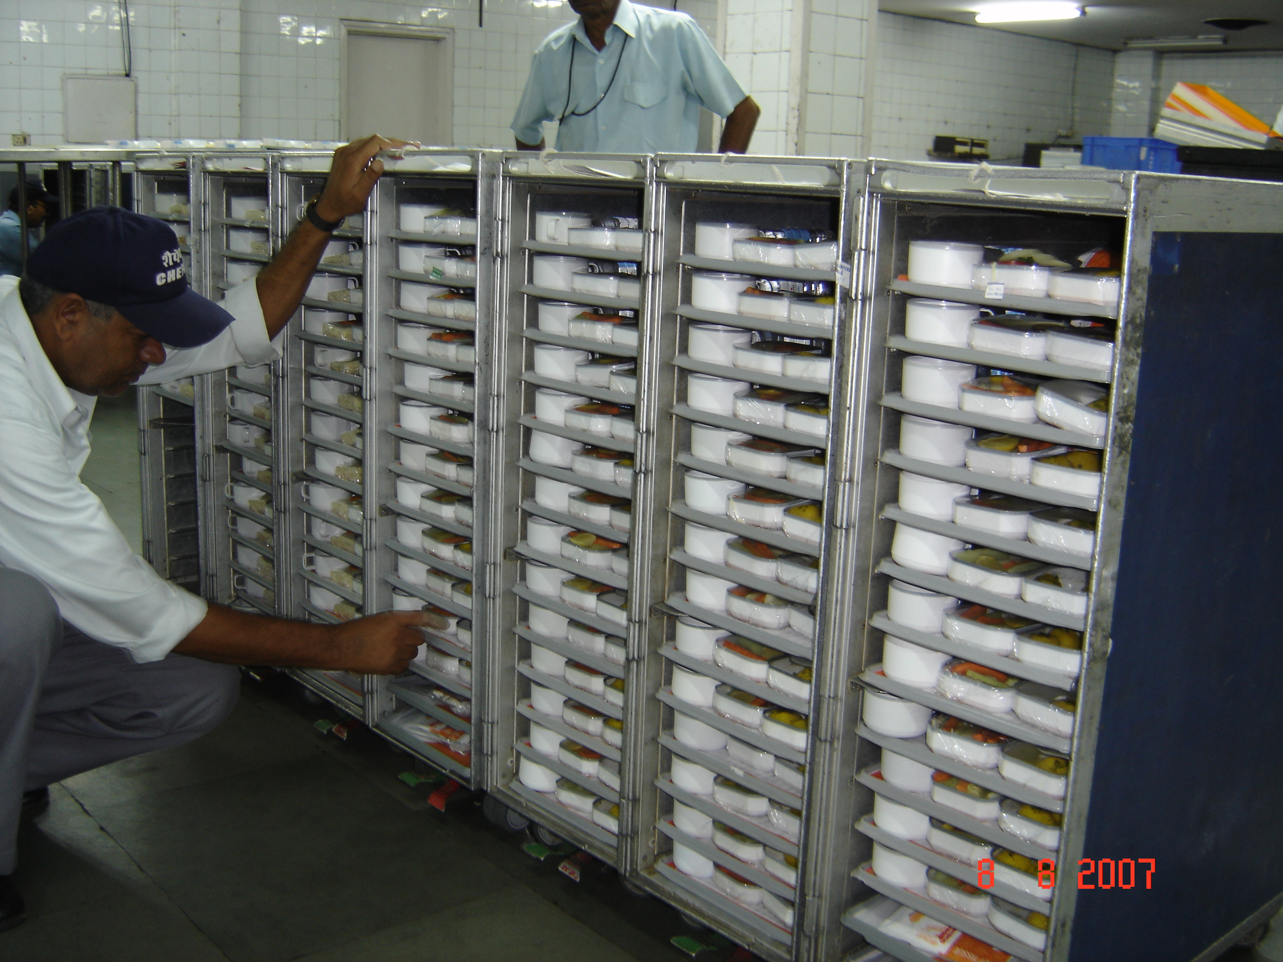←

- Presetting of food - Tray Assembly

  - The activity of placing various food items on a tray is called presetting and the entire activity is called Tray assembly.
  - Air India Catering-section informs the passenger load and any changes in the uplift and type of aircraft.
  - As per the load given by the airline, type of uplift and the laid down menu of the day as given by the airlines from time to time, a Kitchen Order Ticket (KOT) is plac
  - The flight supervisor makes the preset list, tags for meal trolleys and for oven cages as per passenger load and galley loading plan for that particular aircraft.
  - The staff allocated for presetting of trays for the flights presets the trays for J/Class, Economy Class, special diets, Crew as per the flight.
  - After completion of presetting, the trays are put in the meals trolleys as per the tags for the meal trolleys given by the supervisor.
  - The trays are not kept lying either on the table or on the conveyor. These should immediately be put in the trolleys.

Contd……12/-

Page 12
Annexure:II

  - As per the oven cage tags, the supervisor fills the ovens in the kitchen as per the uplift/menu of the flight in consultation with the Chef on duty.
  - These duly filled oven cages are also kept in the cold room along with the meal trolleys of the flight.

← Economy Class meals are being checked.

- Preloading Chilling
Completed flight – J/c Tray setups, Economy Tray setups, Crew Tray setups and special diets – all in meal trolleys as per the flight trolley tags given by the supervisor are immediately put in the holding area (a cold room meant for chilling the meals). Under no circumstances the trolleys are kept out side.

    - Airline Stores / Bond Stores
- Majority of consumables and non-consumable equipment are provided by the airlines. If the items are locally procured by the airlines then the airline’s local stores directly issue these. If the items are imported then these items are issued after completing custom bond formalities. The items are issued on weekly basis but in case of non-availability of certain items on the weekly stores day, these items have to be issued on any other day. Staff along with supervisor has to be sent to Catering-Stores to get the items issued.
- Dry Stores Packing: As per the directions from the airlines the dry store items are packed as per the flight schedule. These items include teabags, coffee, sugar sachets, milk sachets, salt-pepper sachets, tooth-picks, paper hand towels, paper napkins, toilet rolls, garbage bags etc.
- Issuance of items to flight presetting: all consumable items are issued to the staff that would be presetting the trays or staff that would be making cutlery sets etc.
- HCI/Chefair staff looks after the supervisory part of this activity.

Contd…..13/-

Page 13
Annexure:II

    - Preloading flight Assembly, Checking & Security Check
Before the items are loaded in the hilift, all the ready flight equipment is taken out from the cold room/s are assembled at one place. The dry stores including bulk water bottles, juices, soft drinks, glasses (glass and disposable paper), milk packets etc. are also put in the respective places in the meals trolleys. The completed flight items are checked by the supervisor and then it is handed to Chefair and airlines security who checks the flight and seal all the items either by metal, plastic or paper seal.

    - Loading in the hilift
After the security check of the flight and checking from the airlines whether the flight is on time, the flight equipment is loaded in the hilift as per the system and is secured through a belt. The supervisor does a final checking and then the hilift is released for the airport. (Back to a)

    - Following are some instances/changes:
- There are situations where the uplift may change after presetting is complete. In these cases the tray setups have to be changed and ovens refilled as per the new uplift. This may happen even at the last minute.
- The load may increase/decease at the last minute.
- The type of aircraft may change at the last minute, which may necessitate re-organizing flight as per the new aircraft.
- Change of aircraft at the tarmac – There may be instances where catering equipment may have to change to other aircraft due to snag etc., even after loading on the first aircraft.

    - Following is a typical flight schedule (only for example):

SN |  | Sector | Type of Aircraft | Frequency | Dep  Time | Hilift  Time | J/C  Uplift | Ecy Uplift | Crew Uplift | Arrival/  Offloading
1 | 51 | DEL/PNQ | A320 | 1,2,3,4,6,7 | 0500 | 0330 | B | B | CB
1 | AI 852 | PNQ/DEL | A320 | 1,2,3,4,6,7 |  |  | B | B | B | 0925
2 | AI 3449 | DEL/IXL | A319 | 2,4,5,6,7 | 0630 | 0500 | B | B | B
2 | AI 3450 | IXL/DEL | A319 | 2,4,5,6,7 |  |  | B | B | --- | 1000
3 | Ai 401 | DEL/CCU | A321 | DAILY | 0800 | 0630 | HT | HT | HT | 2200
4 | AI 879 | DEL/IXB | A319 | DAILY | 1100 | 0930 | HT | HT | HT
4 | AI 880 | IXB/DEL | A319 | DAILY |  |  | L | L | L | 1630

Contd….14/-

Page 14
Annexure:II

- It can be seen from the above that AI 851/AI 852 is one flight with double uplift operates 6 days a week whereas AI 401 is a single uplift flight operates daily with A321 aircraft.
- AI 851/852 is a double uplift flight, which has uplifts on two sectors but only one time loading/off-loading on the aircraft.
- AI 401 is a single uplift flight, which has uplift on one sector only and one time loading/off-loading on the aircraft.

Service Provider’s Role :
i) As described in the flow chart above, the service provider has to perform all the activities in totality – from washing of equipment to presetting of trays to entire tarmac activities.
- The service provider will provide sufficient manpower including supervisors and managers required to handle/manage the above activities on round-the-clock basis as per the requirement in consultation with Incharge - Flight Operations, Chefair-Delhi.
        - Sufficient manpower will be provided to bring stores items including consumables and non-consumables from Catering-Stores.
(iv) Electricity and Water will be provided by HCIL/Chefair.
(v) All cleaning material including soaps, rinse, cleaning agents etc. of branded quality meant for dishwashing machine and wiping material will be provided by the service provider.
(vi) Major machines like dish washing machines, cutlery / glass washing machines, sinks etc will be provided by HCIL/Chefair. The service provider will have to keep the dishwashing and other machines clean and maintained at all times. Damages to any of the equipment will be the responsibility of the service provider and the repair cost will be debited to him on actuals.

Compliance of Food Safety Norms/Rules
a) Food safety and hygiene are the essence of any food industry including flight catering. The service provider should be well versed with the food safety norms.
b) The service provider should be able to provide services according to food safety and HACCP guidelines.
c) The emphasis will be on the cover all cleanliness of the area as well as the personal hygiene of the staff deployed.
d) The staff uniform given by Service Provider should also consist of disposable gloves, masks and caps.
e) The staff uniform should be clean at all times.
d) On time performance is a major requirement of flight catering which must be kept in mind at all times.
- The supervisors should be able to brief the staff on continuous basis in regard to their duties.

Contd….15/-

Page 15
Annexure:II

20. Other responsibilities of the Service Provider ;
        - The service provider will obtain at its own costs, security clearance and police verification for its entire staff.
        - The service provider should arrange for BCAS passes for its staff on its own and its own cost.
        - The service provider will allow Hotel Corporation of India and airport security agencies to search its staff before and after entering/leaving Hotel/Flight Catering premises and airport.
        - The service provider will provide proper uniforms and Identity cards / badges to its staff employed by it for providing the aforesaid services and ensure that the staff is always in proper, neat and clean uniform.
        - Hotel Corporation of India will not be responsible for contravention of any Government rules and regulations by any of service provider’s staff and it shall indemnify HCI for the same.
        - The service provider shall ensure the quality of work performed by its staff and in case of any complaint against a particular person; the service provider shall have to replace such staff. In case of non-compliance of this condition, HCI shall have right to refuse entry of any such staff.

- The service provider will ensure that no staff is under the influence of any addiction/alcohol while on duty.
- The service provider will ensure that all security regulations of HCIL, BCAS, DIAL and/or any other agency associated with airport security is strictly adhered to and complied with.
- Staff transports will be the service provider’s responsibility.
- Service provider will provide medical facilities to its employees.
- The reporting pattern of supervisors/staff will be informed at the time of start of the contract.
- Prompt, punctual, efficient, safe, courtesy and quality are the essence of this service.
- The service provider will provide a list of all staff engaged with the contract.
- The service provider will provide related telephone numbers to HCIL officials.
- The service provider will keep attendance records of all the staff duly signed by the official/s authorized by CFCD.
- The service provider shall be solely and wholly responsible to provide services as outlined above, under any circumstances, without offering any excuse, on religious or other grounds such as state of industrial relations in the establishment, etc. The service provider shall make every endeavor to fulfill its commitments to the entire satisfaction of HCI.
- The total cost of the items will be deducted from the bills if any item belonging to HCI/Lounge is found broken due to negligence of the service provider’s staff. In this regard, the decision of HCI will be final.
- The service provider will meet all statutory requirements including registration under ESI/PF Acts, etc. in terms of personnel as per Government guidelines as applicable from time to time & other matters and will solely be responsible for its acts.
Contd…16/-

Page 16
Annexure:II

21. Penalties
- The penalties for non-conformity to the scope of service may be levied up to a maximum of 5% of the total value of the contract.
- The service provider will keep Registers / Log books / Challan books for getting the signatures of the authorized officials of both the Units of HCI on daily basis, for completion of jobs which will further be submitted along with the bills and will form the basis for the payment.
- In case lapses in the services are reflected in the Registers / Log books / Challan books, same will be discussed between the authorized representative of the service provider and the HCI official before onward submission for billing, which will be binding on the service provider.

22. Other Information
- The service provider will indemnify the HCI (including legal expenses and consequential loss) for any loss including third party claim on HCI due to any reason or damage to HCI or equipment resulting in interalia from the service provider’s negligence, service provider’s staff or equipment.

- For the above liability purposes, the service provider shall maintain an adequate insurance coverage to be mutually agreed upon, with a reputed insurance company.
- The billing cycle will be one month.
- The service provider will meet all statutory requirements in terms of personnel & other matters and will solely be responsible for its acts.

***

HOTEL CORPORATION OF INDIA LTD.

ANNEXURE –III

C E R T I F I C A T E FOR UNCONDITIONAL ACCEPTANCE OF TERMS & CONDITIONS OF THE TENDER (TO BE SUBMITTED WITH TECHNICAL BID- PART A) ON TENDERER’S LETTER HEAD)

To,

The Dy. Manager – Purchase,
Corporate Purchase Section,
Hotel Corporation of India Ltd,
Centaur Hotel,
IGI Airport-II, New Delhi -110037

Dated:

Sir,

Sub: C E R T I F I C A T E FOR UNCONDITIONAL ACCEPTANCE OF TERMS & CONDITIONS, SPECIFICATIONS OF THE TENDER

Tender No. DEL/09/2014-15/ ,Dated: 08.4.2014 , Due on; 15.05.2014

Sub: Flight Operations Services at Chefair Flight Catering, New Delhi.

It is certified that we have studied and understood and hereby agree for the terms and conditions and specifications of the subject Tender issued by “HCIL”,

AUTHORISED SIGNATORY
COMPANY SEAL

ANNEXURE- IV
HOTEL CORPORATION OF INDIA LTD.

TECHNICAL BID FORM – PART A

Tender No. DEL/09/2014-15/ ,Dated: 08.4.2014 , Due on; 15.05.2014

Sub: Flight Operations Services at Chefair Flight Catering, New Delhi.

1. | Name of the Bidder / Co.
2 | Complete Address of the bidder/Co.
3 | Telephone No. / Mobile No./ Fax No.  /email ID
4 | Name of Contact Person & mobile.
5 | Whether copy of latest electricity bill of bidder / Co. enclosed as proof of 3 above. (Must) | Yes / No
6. | Whether EMD of Rs……… /- enclosed. Original DD/Cash receipt to be enclosed. (Must) | Yes/No | DD/Cash Receipt No. ……  Date………………….
7. | Whether EMD exemption sought | Yes / No
8 | In case, yes to 8 above, whether the bidder is regd. with NSIC under its single point regn. programme. | Yes / No
9 | In case, yes to 9 above, whether self attested copy of valid NSIC Regn. Certificate enclosed. | Yes / No
10 | Whether Tenderer is having 3 yrs experience for providing Flight Operations Services (Must). A list of clienteles together with the order copies to be enclosed in support of experience.
11 | Whether having PAN/GIR regn No. A self attested copy to be enclosed. (Must) | Yes/No | Regn No……,Date….
12 | Whether Tenderer is having an average turnover of Rs. Lacs per year for last 03 Fin yrs i.e. 2010-11,2011-12, 12-13 . Self Certified copy of ITR , Balance Sheet, Profit and loss account duly verified by Regd. Chartered Accountant to be enclosed in support. (Must) | Yes/No | 2010-11: Rs………….  2011-12: Rs………….  2012-13: Rs…………..

Contd..2/-

Page:2
ANNEXURE- IV

14 | Whether self attested copy(s) of Income Tax Returns for last 03 Financial years - 2010-11,2011-12, 12-13 enclosed. (Must) | Yes/No | 2010-11: ………….  2011-12: ………….  2012-13: ………….
15 | Whether self attested copy(s) of Profit & Loss a/c for last 03 Fin years-2010-11,2011-12, 12-13 . enclosed in support of proof for Turn over. (Must) | Yes/No | 2010-11: ………….  2011-12: ………….  2012-13: ………….
16 | Whether having Service Tax Regn. Self attested copy to be enclosed. (Must) | Yes/No | Regn No………….,  Date……………….
17 | Whether Certificate for unconditional acceptance of all the terms and conditions of the tender on the Bidder’s letter head enclosed as per format (Annexure-I). (Must) | Yes/No
18 | Whether details of institutional Customers enclosed.(Optional ) | Yes/No
19. | Are you already doing business with HCI or any of HCI Units in your or under some other name? If so, what name? | Yes/No
20. | Has your company been Black Listed by any agency of the Airport or else where. If yes, please give details. | Yes / No | If yes, details. ………………

21. Undertakings : To be agreed & signed by the tenderer(S)

- It is confirmed that we have the capability & capacity to supply the material for which we have quoted rates in the Financial Bid Form – Part –B as per terms & conditions of the tender.
- It is also confirmed that we have carefully gone through and have understood and hereby agree to abide by all the General Terms & Conditions and Specifications governing the tender.
- It is also confirmed that I am authorized to sign the tender documents and the information given is true and correct to the best of my knowledge and belief and nothing material is concealed.
- It is also confirmed that the documents attached in support of the details filled in the Technical Bid Part –A above are correct.

Signature: _______________________________

Name & Designation: _____________________

Co. Name & Seal: _________________________

Date: ___________

Place: __________

*************
HOTEL CORPORATION OF INDIA LTD.

ANNEXURE- V

PRICE BID FORM – PART B

Tender No. DEL/09/2014-15, Dated: 08.4.2014 , Due on; 15.05.2014

Sub: Flight Operations Services at Chefair Flight Catering, New Delhi.

1. | Name of the Bidder / Co.
2 | Complete Address of the bidder/Co.
3 | Telephone No. / Mobile No./ Fax No.  /email ID
4 | Name of Contact Person & mobile.
5.0 | Rates for providing Flight Operations Services at Chefair Flight Catering, New Delhi.  as per work scope and as per terms of the Tender.
 | Rates Rs. Per Flight
5.1 | Rates Rs. Per Flight for Single Sector Flight | Rs…………………..per Flight.
5.2 | Rates Rs. Per Flight for Double Sector Flight | Rs…………………..per Flight.
5.3 | L-1 CRITERIA : | L-1 Bidder shall be decided based on the L-1 average rates quoted at 5.1 and 5.2 above that is (Rs.at 5.1 + Rs. at 5.2)  2

- Inclusion and Exclusions, Govt. taxes and levies applicable to quoted rates.

a) Inclusions:
The rates quoted in the tender shall be inclusive of Government Taxes and levies, cost of manpower, cost of raw material such as cleaning agents and detergents, Airport Entry permit fee, Dial training cost, Provision for Name Badges & Uniform including High visibility jackets, ID Cards and all statutory payments like ESI / PF etc.
b) Exclusions:
i) The Service Tax (including education cess) , if applicable on these services, shall be excluded. Service Tax, if applicable, would be paid / reimbursed separately as per prevailing rates, on submission of receipt as proof for payment together with monthly bills.
ii) DIAL charges, if any, shall be excluded from the above quoted rates. Any additional charges /levies imposed by DIAL would be re-imbursed separately by HCIL on production of receipt as proof of payment.

Contd..2/-

Page:2

ANNEXURE- V

7. Rates quoted in the Tender shall be valid for 120 days from the date of opening
of technical bids for consideration of HCIL.

- It is confirm that I am authorized to sign tender documents.

Signature: _______________________________

Name & Designation: _____________________

Co. Name & Seal: _________________________

Date: ___________

Place: __________

