Hotel Corporation of India Ltd.
Corporate Purchase Department.
Centaur Hotel, IGI Airport
New Delhi-110037

Public Tender Notice

Public Tender No. | DEL/17 /2014-15, Dtd. 18.9.2014
Flight Operations Services including Tarmac activities at Chefair Flight Catering, IGIA, New Delhi-110037.
Estimated Tender value | Rs. 1.85 crores per annum.
Last date/ time for collection of Tender | 1200 hrs 18.11.2014
Last date/ time for submission of Tender | 1500 Hrs on 18.11.2014
Date/ time for opening of Tender | 1530 Hrs on 18.11.2014

For further details regarding tender documents, please visit our website www.centaurhotels.com.
Amendments (if any) shall be hosted only on HCIL website 07 days prior to opening of the tender and no separate intimation for amendment / extension of due date shall be published in the newspapers.

s/d
Dy. Manager (Purchase)

Hotel Corporation of India Ltd.
IGI Airport, Terminal-2
New Delhi-110037.

Public Tender No. DEL/17/2014-15 , Dated: 18.9.2014 , Due Date ; 18.11.2014

Sub: Flight Operations Services including Tarmac activities at Chefair Flight Catering, New Delhi.

Tender Details

Hotel Corporation of India Limited, here after referred as ‘HCIL’, a wholly owned subsidiary Co. of “Air India Ltd” invites sealed /closed quotations in Two Bid system (i.e. Tech. Bid-Part A & Price Bid – Part B) from reputed Service providers for Flight Operations Services including Tarmac activities at Chefair Flight Catering, IGIA, New Delhi -110037, offering competitive rates and quality services. Offers made should be best / lowest rates as applicable to Govt. Deptts, Public Sector Companies or Institutions.

Tender details :

i | Public Tender Enq. No. | DEL/17 /2014-15
ii | Tender date. | 18.9.2014
iii | Last date / time of submission of tender | 18.11.2014 by 1500 hrs.
iv | Due Date / time of opening of technical bid | 18.11.2014at 1530 hrs.

2. Tenderers are requested to submit their quotations as per following documents :

i | General Terms & Conditions | Annexure- I
ii | Prequalification / Technical Evaluation Criteria | Annexure-II
Iii | Specifications Of the Material | Annexure-III
Iv | Certificate for unconditional acceptance of Terms & Conditions of the tender. | Annexure-IV
V | Technical Bid Form- Part A. | Annexure-V
vi | Price Bid Form Part B | Annexure-VI

3. Estimated Tender Value : Rs. 1.85 Crors (approx.) per annum, which may vary as per operational requirements.

4. EMD Payment : EMD of Rs. 50,000.00 must be paid with the Technical bid-Part A.
EMD is payable in the form of DD / pay order / Cash only. In case EMD is paid by DD, the DD should be in favour of Hotel Corporation of India, New Delhi payable at New Delhi. In case EMD is paid in cash, it should be deposited on or before tender due date at HCIL Cash counter and receipt be obtained. Original DD or Cash receipt, as the case may be, must be enclosed in original with Technical bid form-Part A.

5. Method of submission of Quotations in Two Bid System :
i. Envelope One ( Technical Bid - Part A ) :- shall contain duly filled “Technical Bid Form – Part A”( Annexure – III), EMD DD Of Rs.50,000.00 together with the self attested photocopies of supporting documents. The envelope should be super scribed with: Envelope One – “Technical Bid- Part A” for “Tender No. DEL/17/2014-15, dated : 18.9.2014, Due Date: 18.11.2014.
ii. Envelope Two ( Price Bid Form – Part B) : shall contain duly filled “Price Bid Form- Part B” (Annexure IV). The envelope should be super scribed with: Envelope Two –“Price Bid- Part B” for “Tender No. DEL/17/2014-15, dated : 18.9.2014, Due Date: 18.11.2014.
Contd..2/-
iii. Envelope Three (Master Envelope) : The above two sealed / closed envelopes (Envelope One and Envelope Two) must be put in the “Third / Master Envelope” which should be super scribed with “Quotation for Tender No. DEL/17/2014-15, dated- 18.9.2014, Due Date: 18.11.2014”.

6. Name of the tenderer / Co. and Address/ phone no./email id to be written at the bottom of all the three envelopes for identification purpose.

7. Both the Bids must be completed in all respect and all pages including supporting documents must be signed by the authorized signatory of the bidder and all pages should bear Co. Stamp also.

8. The tenderer(s) may use “HCIL” Tender Documents for applying to this tender and in this case, must put their Co’s Stamp on each page and each page be signed by the Authorized signatory of the Tenderer / Co. For submission of Price Bid, Tenderer can use their Co.’s letter head and in this case, format of Financial bid has to be typed in the manner and form as shown in Annexure-vi of the tender.

9. The tenders should be submitted at the following address on or before 1500 hrs. of 18.11.2014.

Deputy Manager-Purchase,
Corporate Purchase Section,
Centaur Hotel,
IGI Airport, New Delhi-110037.

10. The perspective bidder(s) may send their offer(s) in sealed / closed envelope through Dak / Courier or by messenger so as to reach at the above mentioned address on or before 18.11.2014 by 1500 hrs. However, sending tenders by Dak / courier services may be at the risk for not reaching in time. Therefore tenders doing so, must ensure that their tender(s) reaches at above address well in time.

11. The tender closes on 18.11.2014 at 1500 hrs. The closing date may be extended at the sole discretion of ‘HCIL’.

12. The Technical Bids shall be opened first on the due date / time of the tender.

13. Tenderers who wish to attend tender opening may do so OR send their representative with authorization letter on their Co.’s letterhead signed by their authorized signatory which should be produced at the time of opening of tender at above address / time.

14. HCIL’ reserves the right to reject any tender in part or full or annul the tender process without assigning any reason.

15. The Commercial Bids of only technically suitable vendors will be opened subsequently. The date / time of opening of same will be advised to the qualifying vendors only. No enquiries / correspondence shall be entertained in this regard.

16. Tender documents have been hosted on our website: http://www.centaurhotels.com also.

17. This is a limited tender and quotations are invited only from the parties registered with Hotel Corporation of India/ Centaur Hotels New Delhi.

18. The parties who are not registered with Hotel Corporation of India/ Centaur Hotels, New Delhi may do so for future Tenders.

19. For any clarifications Dy. Manager-Purchase, HCI, New Delhi-110037 may please be contacted on Ph. No. 011-25607613, email ; purchasehci7606@gmail.com.

s/d Deputy Manager-Purchase

Hotel Corporation of India Ltd.
IGI Airport, New Delhi-110037.
Annexure:I

Public Tender No. DEL/17/2014-15 , Dated: 18.9.2014 , Due Date ; 18.11.2014

Sub: Flight Operations Services including Tarmac activities at Chefair Flight Catering, New Delhi.
General Terms and Conditions

1. ‘HCIL’ as used in the Tender document means “Hotel Corporation of India Ltd ”.

2. “Contract” means the Contract for providing Flight Operations Services including Tarmac activities at Chefair Flight Catering, IGIA,T-2, New Delhi-110037.

3. The “Successful Tenderer” OR “Service Provider” OR “Party” OR “Contractor” as used in the Tender document, shall mean the one who has been declared as
i) Lowest bidder .
ii) Whose tender is under consideration for award of Letter of Intent (LOI)/ Contract.
iii) Received Letter of Intent (LOI)/ Contract for commencement / execution of services.

4. The “Tenderer/ bidder ” as used in the Tender document, shall mean the one who has signed the tender form and submitted the quotation in response to our tender notice.

5. It is further clarified that any individual signing the tender or other documents in connection with the tender must certify whether he signs as:
i) A "Sole Proprietor" of the firm or constituted attorney of such sole proprietor.
ii) A partner of the firm, for partnership firm, must have authority to refer to arbitration, disputes concerning the business of the partnership by virtue of either the partnership agreement or a power of attorney. Alternately, all the Partners should sign the tender.
iii) Constituted attorney of the firm, if it is a Company.
iv) An authorized signatory of the firm.
v) A Karta of HUF in case the firm is constituted under HUF.

6. The Bids shall be evaluated / compared on the basis of details filled in the tender form and documents provided by the bidder with the Tender form.

7. Offers should be valid for a period of 120 days for consideration of HCIL from the date of opening of Technical bids.

8. Earnest Money Deposit (EMD) :
- The Tenderer will furnish along with Technical bid form, an EMD of Rs. 50,000.00 (Rupees Fifty Thousand only) in the form of DD/Pay Order drawn in favour of “Hotel Corporation of India” payable at New Delhi. Or may deposit cash at Cash Counter at Centaur Hotel, IGIA,New Delhi. The original DD or cash receipt must be enclosed with the Technical bid form-Part A.
- EMD in any other form shall not be accepted and if done so, the tender shall BE out-rightly rejected.
- Tenders received without EMD/ lesser amount of EMD will be rejected.
- EMD deposit shall not carry any interest.

Contd. …2/-

Annexure:I
- In case of violation of terms of the tender, EMD shall be forfeited.
- In case, the successful Tenderer refuses to accept the LOI/Contract or fails to abide by any terms of the Tender/fails to commence the work within stipulated time without valid reasons, EMD shall be forfeited.
- In case of successful Tenderer, EMD can be adjusted in Security Deposit.
- In case of unsuccessful Tenderers, EMD shall be refunded without interest, within a reasonable time after finalization of the Tender.
- In case, the tenderer declines to accept or honor the contract awarded in his favor OR the Tenderer opts out of the tender process, for reasons unknown, after opening of bids, EMD of such tenderer(s) will be forfeited and the tenderer will not be allowed to participate in the next tender of HCIL .HCIL may also blacklist such tenderer for a period of 3 years. The decision of HCIL would be final in this regard.
- Date of EMD DD/PO/Banker’s Cheque should be after the date of issue of Tender Enquiry.
9. Extension of Due Date :
i) The Due date / time of submission / opening of Tender may be extended at any time, at the sole discretion of HCIL.
ii) Incase of any amendments/extensions and clarifications, issued to this Tender, the same will be hosted only on HCIL website: www.centaurhotels.com and HCIL will not issue any Press Advertisement or intimate the Tenderers individually of the same. Therefore, Tenderers are advised to visit HCIL website regularly till the closing date of the Tender.
iii) In case, there is a change in Work-scope or Other Terms & Conditions of the Tender after publication of the NIT but before its due date, the last amendment, if any, will be hosted on HCIL website minimum of seven days before the amended due date of the Tender. The vendors, who have submitted their response before last amendment, shall have an option to re-submit their bids, before the amended due date, if they choose to do so.
iv) In case, a revised bid is received before the due date, then only the revised bid will be considered and the original bid will not be opened.

10. Submission of Bids :
i) Tenderers are advised to study the tender documents carefully. Submission of tender shall be deemed to have been done after careful study and examination of the tender documents with full understanding of its implications, nature and character of the work to be carried out, operating conditions and other pertinent matters which may affect the contract and / or the cost.
- Tenderers are required to fill up the tender in the prescribed forms only and must be signed by the authorized signatory. All the filled in tender forms and supporting documents should bear signatures of Auth. Signatory and bear stamp of Co./ tenderer.
- Closed /sealed Tenders be deposited in the designated Tender Box on or before due date / time.
iv) Bids should be unconditional. In case of any condition, the bids shall be rejected.
- In case it is found that there is a variation in the documents / data submitted by the tenderer, the bids of such tenderer would be rejected and tenderer would be disqualified and EMD would be forfeited.
- Rates quoted be clearly written / typed both in words and figures without any Overwriting. Overwriting, if any, should be counter signed by the Tenderer. In case of any discrepancy, the amount written in words shall be considered as final for the purpose of comparison of rates. However, decision of HCIL shall be final in this regard.
Contd..3/-
Page;3
Annexure:I
vii) Tenders not accompanying required information and documents are liable to be rejected. Any request for subsequent submission of any information/documents will not be entertained. However, HCIL may seek clarifications or call supporting documents for verification during evaluation process.
viii) Tenders sent through Post or Courier will be at the risk of the Tenderer and HCIL will not be responsible for any loss or late receipt or non-receipt of the Tenders.
ix) Tenders received after due date / time will not be entertained.

11. Undertakings: The successful tenderer, on award of LOI / Contract, shall abide by the following conditions:-
- That they shall start required Services under the contract at Delhi within 30 days from the date of acceptance of LOI / contract.
- That all the provisions of the contract Labour (Regulation & Abolition) Act 1970 shall be complied with, if the same are applicable to them and he shall obtain at his own cost and initiative, license under the contract labour (Regulation & Abolition) Act 1970 from the concerned authorities within 15 days of receipt of LOI / Contract for which necessary Form – V shall be furnished by HCIL.
- Varifications of Licences / Registrations: That they agree that the registrations and licenses under all the applicable local and central taxes and laws i.e. Service Tax / Provident Fund Act / Income Tax Act / Shop & Establishment Act / ESI Act etc. shall be produced for verification/checking of HCIL or to the third party authorized by HCIL / agencies of Govt. of India.
- That the requisite work as per enclosed Work Scope (Annexure-II) would be executed to the satisfaction of HCIL.
- That on the spot surprise checks could be conducted by HCIL / third party authorized by HCIL, anytime and shortcomings found, if any, shall be overcome within the given time or if not corrected the same shall be penalized by HCIL as per penalty clause of the Tender.

12. Award of LOI / contract to the successful bidder would be subject to compliance of the eligibility criteria & undertakings as specified in the Tender and the LOI / contract would be withdrawn, if these requirements are not fulfilled.

13. Tenderers shall give the official mailing Address, Phone/ Fax Numbers, EMAIL ID to which all correspondences shall be sent by HCIL. Also if address is changed in due course, the same shall be intimated to HCIL immediately.

14. HCIL reserves the right to accept or reject any/or all bids, annul the Tender process and reject any or all the bids at any time prior to the award of Contract without incurring any liability to the affected Bidder(s) / Tenderer(s) or without any obligation to inform the affected Bidder(s)/Tenderer (s) on the grounds of such annulment / rejection.

15. Any notice by one Party to the other pursuant to the Contract, shall be sent in writing to the address specified for that purpose in the Contract.

16. The successful Bidder shall not sub-Contract the Work or any part thereof to any other person, concern, firm or company without prior approval of HCIL.

Contd..4/-
Page;4
Annexure:I
17. Claims for damages :
- HCIL shall notify the Tenderer of any claims / deficiency arising under / out of the Contract which shall be rectified by the tenderer within the given time failing which HCIL may take a remedial action without any further notice at the Tenderer’s risk & cost.
- In case, the deficiencies / shortcomings of the tenderer or its personnel are repeative in nature and or damaging the image of HCIL, HCIL may impose penalty and terminate the Contract without prejudice to any other rights, which HCIL may have on the Tenderer under the service Contract.

18. Payment of monthly wages to the staff deployed :
- The Tenderer shall pay wages for the previous month to his employee so deployed for the Work, not later than 7th of following calendar month.
- “HCIL ” shall not be responsible for payment of wages and or any other emoluments to the staff deployed and it shall be the sole responsibility of the Tenderer to make payment to the said workers in time and the Tenderer shall at all time keep “HCIL” indemnified against any such claims from its workers in this regard.
- All records, documents under various statutory provisions including ESI / PF / Disbursement of monthly Wages etc. shall be maintained by the Tenderer and shall be open for inspection of an authorized representative of HCIL / third party authorized by HCIL and or Government Agencies.

19. Validity of Rates & validity of contract :
- Validity of contract : Contract will be valid for a period of one year and extendable for further period of one year on mutually agreed terms depending upon satisfactory performance of the party. However, HCIL, can extend the contract for 03 months at same rates terms and conditions.
- The validity of Agreement comes to an end IPSO FACTO by efflux of time unless or otherwise renewed.
- Validity of Rates : Rates agreed to in the Contract shall remain firm for contract period and no request for further price escalation on any ground shall be entertained during the Contract period including extensions, if any, except for increase in the minimum wages as increased by the Govt. of NCT of Delhi. However, no increase shall be applicable in the minimum wages up to + 10% increase over the minimum wages as applicable on due date of the Tender.
- Inclusions : The rates quoted in the tender shall be inclusive of Govt. Taxes and levies, Capital Cost, cost of equipments, Manpower cost , cost of raw material- cleaning agents and detergents, Airport Entry permit fee, Dial training cost, cost of providing Name Badges/ID Cards / Uniform including High visibility jackets, statutory payments like ESI / PF etc.
v) Exclusions: The Service Tax (including education cess), if applicable on these services and DIAL charges, if any, shall be excluded from the quoted rates. In case Service Tax and DIAL charges are applicable on this contract and if paid by the tenderer, the same shall be reimbursed to them on submission of receipt as proof for payment together with monthly bills.

20. Rates quoted in the Tender shall be valid for 120 days from the date of opening of technical bids for consideration of HCIL.
Contd..5/-

Page; 5

Annexure:I
21. Price negotiation :
It is not the general practice of HCIL to carry out price negotiations following opening / evaluation of the bids. Therefore, Tenderers are advised in their own interest to offer their best quotes in response to this Tender. HCIL, however, reserves the right to carry out negotiations in exceptional cases with the L-1 Tenderer, if required.

22. Award of contract / LOI, acceptance, commencement/execution & validity:
The award of Contract / LOI to the successful bidder shall be subject to the following:-
i) That the tenderer undertakes to fulfill the eligibility criteria, agrees for undertakings and the terms & conditions of the tender.
i) The Tenderer has to convey acceptance of LOI (Letter Of Intent) within 7 days of receipt of LOI.
ii) The Tenderer has to submit the security deposit of 5% of one year contract value in the form of DD / Pay order / Bank Guarantee from a scheduled Bank at the time of commencement of the job but positively before submission of 1st Bill.
- The Tenderer should commence the services within 30 days from the date of the acceptance of LOI or as specified in the LOI.
- The Tenderer has to execute an agreement of terms & conditions of the contract on Rs.100/- non-judicial Stamp Paper with ‘HCIL’ within 30 days of receipt of LOI / contract and before commencement of services.
- In case, the successful tenderer is unable to commence the services within 30 days from the date of acceptance of LOI, he / she has shall keep HCIL apprised of the reasons and circumstances for the same. In case, HCIL is not satisfied with the reasons for delay, HCIL may terminate the LOI /contract and shall be free to take further action as deemed fit including action of re-tendering. Such defaulting party shall not be allowed to apply in the next tender and also may also be black listed for further 3 years for other tenders of HCIL. The decision of HCIL would be final in this regard.
- In case, service provider fails to commence the services and the LOI / Contract is cancelled, the EMD of such service provider shall be forfeited besides any other penal action.

23. Responsibility for Acts and behaviour of the deployed staff :
- The Service Provider shall be solely responsible for the acts and deeds of his personnel deployed for ‘HCIL’ duty. HCIL will, in no way, be responsible for violation of any rules/regulations/instructions of the concerned agencies and/or for any loss or damage caused by his personnel to ‘HCIL’ property / Staff and / or third party property. Any such loss or damage caused shall have to be compensated / borne by the service provider.
- Supervision of personnel deployed & equipment’s provided by the Service Provider under the contract ,shall be his responsibility.
- Verification of antecedents of service provider’s personnel will be his responsibility.
- The service provider will provide Name Badges, Identity card, Uniform / High visibility jackets (if applicable) etc to his personnel at his own cost. He will also ensure that the persons wear the uniform and keep it neat, clean and tidy.
- The Service provider shall ensure the quality of services which are performed by its personnel and in case of any complaint against a particular person; the Service provider shall have to replace such personnel failing which, “HCIL”, shall have right to refuse entry of any such personnel.
Contd..6/-

Page; 6

Annexure:I
- In case of operational exigencies, the Service provider shall provide additional manpower / equipments (if applicable) to perform the Work as defined in the Work-Scope and to maintain quality of Work to the satisfaction of HCIL.

24. Exit clause / termination of the contract/agreement : The Contract may be terminated under the following circumstances :
- HCIL may at any time terminate the Contract with immediate effect by giving written notice to the Tenderer/ Bidder, if Bidder becomes bankrupt or otherwise insolvent, provided that such termination will not prejudice or affect any right of action or remedy which has accrued or will accrue thereafter to “HCIL”. In this case no compensation shall be made available to the Bidder.
- In case of unsatisfactory performance or breach of any of the clauses of this Contract, HCIL shall issue a notice of 30 days to the party to rectify the breach and improve the performance failing which HCIL shall be at liberty to terminate the Contract /Agreement
by providing a 30 days written notice to the party. The Tenderer/Bidder shall not have any right to dispute or question the judgment of ‘HCIL” on its unsatisfactory performance.
- In case of change in situation/circumstances/operational requirement etc, “HCIL” shall have the right to terminate the Contract by serving a 30 days written notice to the Tenderer / Bidder. In this case, the Tenderer / Bidder shall not have any right to claim damages compensation from “HCIL”
- The successful Tenderer shall also be at liberty to terminate the Contract by providing to HCIL a 30 days written notice. However, during notice period, the service provider shall ensure compliance of all contractual obligations as had been doing earlier.
- On termination of the Contract, the Service Provider shall handover all the documents related to the services rendered and all equipment’s / fittings including Furniture, Fixtures, if any, that had been issued to the Service Provider.

25. Rejection of bids : The bids can be rejected for the following reasons :-
i) If the Tender has been received after due date and time.
ii) In case tenders are received at address other than as mentioned in the documents.
- If the bids have been received unsigned or are incomplete.
- If the Tenders are received by fax or email.
- If tenders are received in open condition.
- If both the bids i.e. Technical bid form and Fin. Bid form are received in one envelop.
- If only one bid is received and other bid is nor received.
- If price is indicated in the Technical bid form.
- If the Tender has been received without EMD, lesser amount of EMD or the EMD has been submitted in a mode other than as specified.
- If the Tender is submitted in the different name.
- Ineligible bids shall not be entertained and the decision of HCIL in this regard would be final. No correspondence in the regard will be entertained.
- If tenders received are conditional.
- If tenders are not filled in the prescribed format.

26. Queries from the tenderers during Evaluation process of Bids:
No queries shall be entertained from the Tenderers during evaluation process of bids.

27. Security Deposit (SD):
a) The successful Tenderer, on award of LOI/ Contract, shall deposit, and continue to maintain for the entire period of agreement plus three months, a sum equivalent to 5%
Contd..7/-
Page; 7

Annexure:I
of Annual value of Contract as estimated by HCIL, as S.D. in the form of DD / Pay Order/ Bank Guarantee from a Scheduled Bank. In exceptional cases depending upon merits, ‘HCIL’ would reserve the right to deduct the amount of ‘SD’ from any outstanding invoices of the vendor irrespective of the PO against which the ‘SD’ may be due.
b) The SD has to be deposited at the time of commencement of the Work but positively before submission of 1st Bill.
c) In case, SD is not deposited in time, the bills shall not be processed for payment.
d) In case of breach of Contract or violation of any terms of the Contract the SD shall be forfeited.
e) SD deposit shall not bear any interest, and shall be refunded without interest only on successful completion of the awarded work and on fulfilling of all Contractual obligations.

28. Payment of bills:
- The Service provider shall maintain a shift wise Log Book for attendance of deployed personnel / supervisors for controls. HCIL will have the right to pursue these details for verification of bills submitted by the service provider.
- The service provider has to submit consolidated monthly bills to Sr. Mgr-Kitchen/ user Deptt. CFCD for certification and forwarding of same to Dy.Mgr.(Accounts) for payment.
iii) HCIL will make payment on monthly basis by an account payee cheque within 30 days
of the submission of Bills for the undisputed amount.
iv) No advance payment shall be admissible in any case.
v) Necessary Tax deductions at source towards applicable income tax shall be done as per Govt. rules as applicable from time to time.

29. Indemnification:
  - The Service Provider shall indemnify HCIL against any claims, damages, loss or penalty including costs thereof in case of liability arising out of any accident/incident/theft involving manpower deployed by him/it.
  - HCIL will not be responsible for any injury sustained by Service Provider’s personnel during the performance of their duties and also any damage or compensation due to any dispute between the service provider and it’s personnel. Any expenditure incurred by HCIL to handle any situation arising out of the conduct of personnel deployed by the Service Provider will be made good from SD / Bills of the Service Provider.
  - Compliance of Labour Laws / Statutory Obligations: The Service Provider shall also indemnify HCIL for compliance of all acts, laws, rules and/or regulations (including Labour Laws) and amendments enacted from time to time thereto by any Central/State/Local or Municipal Authorities as also which may be applicable to the Service Provider for this contract.
  - The Tenderer shall indemnify HCIL against payment of penalty / third Party claims / damages / loss of property of HCIL, DIAL, AI / Any other party due to mishandling on the part of personnel provided by the Tenderer.
  - The tenderer shall also indemnify for any liability arising out of any accident / incident involving his vehicles and or employee and shall reimburse any loss or damage to HCIL concerned party. In case, any such amount is not deposited / paid to HCIL , the same shall be deducted from his monthly Bills / SD / Future payments due to the Tenderer.

Contd. 8/-

Page: 8
Annexure:I
  - The Tenderer shall also indemnify to reimburse any loss or damage by his personnel to HCIL personnel or property including machinery, equipment or buildings. In case, any such amount is not deposited/paid to HCIL, the same shall be deducted from Security Deposit/Bills/Future payments due to the Tenderer/Service Provider.

30. Compliance of statutory provisions :
i) The Tenderer shall be responsible for compliance of provisions of Labour Laws (Central/State/Municipal/Local) and Minimum Wages Act, Payment of Wages Act, statutory payments i.e. PF Act, ESI Act, Payment of Bonus Act, Contract Labour (R&A) Act, Bombay Labor Welfare Act, Workmen Compensation Act etc and amendments there to these acts/laws as applicable from time to time.
- The Tenderer shall be solely responsible for any cost and consequences on account of any breach and / or non-compliance of any of the provisions of the Labour Laws. The Tenderer shall indemnify HCIL against any claims / costs / damages and penalties in respect of breach of any of the provisions of the laws in force.
- The employees of the Tenderer shall not be deemed to be employees of HCIL, hence the compliance of the Laws with respect to its/their employee / their welfare will be the sole responsibility of the Tenderer/ Contractor.
- HCIL does not bind itself to provide any Canteen, Medical & Transport facilities to the employee of the Tenderer.
- It shall be the responsibility of Tenderer / Contractor to comply with all liabilities arising out of any provisions of Labour Acts / Enactments hitherto in force or enacted from time to time during the execution of this agreement.
- The Tenderer / Contractor has to ensure that the disbursement of wages to his employees will be made on or before 7th of the following month and also to ensure that the prescribed minimum wages are paid for the applicable category of his employees and a record be maintained.

31. Compliance of Security Regulations:
  - The Tenderer must note that Centaur Hotel and Centaur Flight Kitchen are located in the periphery of IGI Airport, New Delhi and Airport security is under the control of DIAL/GMR/BCAS. In case, Govt of India decides Centaur Hotel and Flight Kitchen have to follow security regulations of DIAL/GMR/BCAS, in that case service provider shall have to comply such security rules without any extra cost to HCIL.
  - The successful tenderer shall have BCAS clearance for his / her Co., if required by Govt of India / A’pt regulator / Airlines concerned within a period of 30 days from the date of arising of such requirement without any extra cost to HCIL failing which LOI/ contract may be cancelled by HCIL.. The decision of HCIL would be final in this regard.
  - Any violation of security regulations and indulging in illegal activities by his personnel will be at the cost / risk of the Tenderer / Service Provider.
  - The Tenderer / Service Provider should ensure verification of character and antecedents of his personnel by Police before deployment, since HCIL is “protected industry”.
  - The personnel so deployed must be in possession of photo identity cards provided by the tenderers under his signatures, company’s name and seal to be shown when demanded by HCIL officials.
  - The Tenderer should have a system to surrender the I Cards of retired / terminated employees to avoid misuse.
Contd. 9/-

Page: 9

Annexure:I

  - The Tenderer/Service Provider shall take responsibility for good conduct of its employee in HCIL premises. If any of its employee is involved in any theft/pilferage of property of HCIL Passenger/ Passenger Baggage/ HCIL property , HCIL reserves the right to impose penalty on the Contractor apart from initiating legal action .
  - It will be the responsibility of the Tenderer/Service Provider to ensure that no unauthorized personnel other than those deployed specifically for the Work gains access to the premises where the services are to be provided.

32. Interpretation :
In the event of any difference in the interpretation of any of the clauses of the Service Contract / Agreement and/or the Tender documents, the clarification given by HCIL shall be final and binding.

33. Relationship:
The relationship shall be on ‘Principal to Principal Basis’. Nothing contained shall be construed or interpreted as constituting a partnership agency or joint venture or any association between the parties. Neither party shall have any right, power or authority to enter into any agreement or act in any manner on behalf of the other.

34. Arbitration :
i) Subsequent to award of contract against this Tender , any dispute or differences, whatsoever arising between the parties out of or relating to the construction, interpretation, application, meaning, scope, operation or effect of the Contract / Service Agreement or validity or the breach thereof, which despite best efforts cannot be amicably settled between the parties shall be referred to “Scope Forum of Conciliation and Arbitration – Govt of India”and the award made in pursuance thereof shall be binding on the parties to the arbitration.
- Jurisdiction :
The construction, interpretation, validity and performance of such Contract /Agreement shall be governed by the laws of land of India. Any disputes arising out of implementation of the Contract between HCIL and Service Provider whatsoever shall be subject to the Jurisdiction of New Delhi / Delhi Courts Only.

***********

Hotel Corporation of India Ltd.,
IGI Airport, Terminal 2, New Delhi-110037.
Annexure:II

Public Tender No. DEL/17/2014-15 , Dated: 18.9.2014 , Due Date ; 18.11.2014

Sub: Flight Operations Services including Tarmac activities at Chefair Flight Catering, New Delhi.

Eligibility Criteria for bidders , staff to be deployed, Scope of Work & Penalties

1.0 Eligibility Criteria for bidders
The prospective bidders / tenderers fulfilling the following pre-qualification criteria as on date of application/ due date of the tender, may apply in the prescribed formats :
  - The tenderer must be Principle service provider having 03 years experience of Inflight Services. A list of clienteles together with the order copies, satisfactory performance certificate issued by the user to be enclosed in support of experience.
  - The tenderer must have ESI, PF, PAN /GIR No., WCT/TIN No/ Service TAX Regn Registrations. Self Certified copy of each to be enclosed.
  - The tenderer must have an average annual turnover of Rs. 62.00 Lacs per year for last three Financial Yrs. i.e. 2011-12,12-13 & 13-14.Self Certified copy of ITRS, Balance Sheet, Profit and loss account for 3 yrs duly verified by Regd. Chartered Accountant to be enclosed in support.
Note: In case tenderer is not making balance sheet or exempted to do so in that case, he / she should enclose copy of 3 yrs bank statement together with certificate of C.A stating 3 yrs Turn over.
  - The tenderer must furnish EMD of Rs. 50,000/- by way of original DD/Pay Order / Cash Receipt. DD/ Pay order has to be in favour of Hotel Corporation of India Ltd payable at New Delhi. In case, EMD is paid in cash, it must be paid at the cash counter of Centaur Hotel / HCIL, New Delhi before submission of tender. Original DD/ Cash receipt must be enclosed with the Technical bid of the tender.
  - The tenderer must also enclose signed copy of certificate of unconditional acceptance of General Terms & Conditions, work scope along with the Tech.Bid Form –Part A,
  - The tenderer must enclose self certified copies of all necessary supporting documents with the Technical Bid Form-Part A.
  - Copy of documentary proof as required above must be furnished along with technical bid and replies such as “Applied for “or “under process” shall not be acceptable. In such cases and in case of not furnishing required information and documents with the technical bid, the tender shall be rejected.

2. 0 Eligibility Criteria for the staff to be deployed ;
- Minimum qualification of the staff deputed should match with respective designation required for Flight Catering Industry.
ii) The staff provided should have the approval of In-charge, Chefair Flight Catering, Delhi.
- All the staff should be medically cleared for working in a food industry by Govt. Hospital.
- The character and antecedents should be verified by the Police Authorities.
- The staff deployed should be of right age as per the Government guidelines.
- Staff provided should be prompt, punctual, efficient, presentable and courteous.

Hotel Corporation of India Ltd.,
IGI Airport, Terminal 2, New Delhi-110037.
Annexure:III

Public Tender No. DEL/17/2014-15 , Dated: 18.9.2014 , Due Date ; 18.11.2014

Sub: Flight Operations Services including Tarmac activities at Chefair Flight Catering, New Delhi.

Scope of Work & Shift wise deployment of manpower and applicable Penalties

1. Shift wise deployment of manpower :-

SN | Activity | Morning shift | Afternoon shift | Night  Shift | Total
i | Loading & off loading catering on /of aircraft inside airport. | 08 | 06 | 04 | 18
ii | Offloading from Hi lift, sorting and dishwashing at CFCD. | 04 | 04 | 02 | 10
iii | Presetting of trays, assembly of flight items, loading in the hi-lift. | 08 | 06 | 04 | 18
iv | Supervisors | 03 | 03 | 03 | 09
V | Managers | 01 | 01 | 01 | 03
 | Total | 24 | 20 | 14 | 58
 | Important notes:
vi | The above manpower is calculated based on workload of 8 double sector flights or 16 single sector flights.
vii | The number of flights may increase/decrease depending upon operational requirement of Air India and allocation of work to CFCD.
viii | The manpower is calculated for the sake of convenience of the service provider / tenderer for calculation of financial involvement on account of manpower. However, the contract will be purely a service contract not a manpower contract.

2. Typical Flight Schedule (only for example):

SN |  | Sector | Type of Aircraft | Frequency | Dep  Time | Hilift  Time | J/C  Uplift | Ecy Uplift | Crew Uplift | Arrival/  Offloading
I | 51 | DEL/PNQ | A320 | 1,2,3,4,6,7 | 0500 | 0330 | B | B | CB
I | AI 852 | PNQ/DEL | A320 | 1,2,3,4,6,7 |  |  | B | B | B | 0925
Ii | AI 3449 | DEL/IXL | A319 | 2,4,5,6,7 | 0630 | 0500 | B | B | B
Ii | AI 3450 | IXL/DEL | A319 | 2,4,5,6,7 |  |  | B | B | --- | 1000
Iii | Ai 401 | DEL/CCU | A321 | DAILY | 0800 | 0630 | HT | HT | HT | 2200
iv | AI 879 | DEL/IXB | A319 | DAILY | 1100 | 0930 | HT | HT | HT
iv | AI 880 | IXB/DEL | A319 | DAILY |  |  | L | L | L | 1630
Contd…2/-

Page:2
Annexure:III
- It can be seen from the above that AI 851/AI 852 is one flight with double uplift operates 6 days a week whereas AI 401 is a single uplift flight operates daily with A321 aircraft.
- AI 851/852 is a double uplift flight, which has uplifts on two sectors but only one time loading/off-loading on the aircraft.
- AI 401 is a single uplift flight, which has uplift on one sector only and one time loading/off-loading on the aircraft.

3. Scope of work / Definitions :
a) Chefair Flight Catering, Delhi in the business of In-flight Catering Services i.e. to supply meals on the Flights of the airlines. The service provider would be required to provide the following services at Chefair Flight Catering, Delhi located at Centaur Hotel Premises, IGI Airport, New Delhi-110037 on round the clock basis.

Flight Operations activity : Will include the following activities :-

Presetting of Food Trays – assembly of flight items – loading in the hi-lift;

Loading and Offloading on/from aircrafts (Tarmac activities) and

Offloading from the hi-lift, sorting and dish washing,

4. Brief of Flight Operations activities involved :
- A flight-catering unit basically supplies food on the aircrafts strictly as per the requirements of the airlines. The food is preset on the equipment given by the airlines like trays, salad bowls, tinfoil dishes etc. These trays etc are then put in Food carts / trolleys or oven cages etc and these trolleys etc are loaded on the aircraft at their specified locations. Used / soiled trolleys etc are simultaneously offloaded and brought back to the unit. This equipment is loaded / offloaded through a high loader truck also known as hilift. Dirty / Soiled equipment is brought back to the unit, sorted, washed, wiped, stacked and prepared for further use on next flights.
- Food is prepared in the kitchen and laid in the equipment given to them by the Flight Operations. Preparation of food in all the departments of kitchen is out of the purview of Flight Operations.
- At present Chefair Flight Catering is catering to Air India domestic flights (narrow body). There are different types of aircrafts, which Air India is operating for its domestic sectors. Following are some of such aircrafts:
- Airbus A321
- Airbus A320
- Airbus A319
- On an average, all the aircrafts have a seating capacity of 170 passengers approximately. Some of the aircrafts have club class or J/Class and Economy class whereas some of the aircrafts have only economy class. The equipment used for J/Class passengers are porcelain whereas equipment used for economy class is melamine.
- With a seating capacity of 170 passengers, the food uplift will be 170 meals for passengers and 8 for the crew members per flight per sector.
- Some of the flights catered by the unit may also uplift food for two sectors i.e. 170 (plus Crew) meals for first sector ex Delhi and another 170 (plus Crew) meals for onward/return sector.

Contd…3/-

Page: 3
Annexure:III
- There are different types of uplifts depending upon the time of departure of the flights. Following are some of the types of uplifts:
- Breakfast
- Hi-tea
- Lunch
- Afternoon tea
- Dinner
- Supper
- Hot Snacks
- The menus uplifted on these flights are given by the airlines. Sample menus are attached as annexure.

5. Equipments used for In Flight catering Services: There are two type of equipment used in in-flight catering that is major and minor .

- Major equipments : Major equipments consists of Meal trolleys, half trolleys, Cabinets, Drawers, oven cages, beverage flasks etc.

- Minor equipments : Minor equipments consists of following :

  - Meal Trays – consists of Large trays , 2/3 trays and Snack trays.

ii) Porcelain Items – consists of Teacups, Saucers, Bread Plates, Large Plates,Side Plates, Salad Bowls, and Casserole dishes.

iii) Butter Dishes : consists of 4 types of items as under :-

    - Glass Tumblers / cutlery & crockery items : such as Large glasses, Juice / Small glasses and Wine glasses.

    - Cutlery Items: such as Teaspoons, Knives, Forks and Dessert Spoons.

    - Melamine items : such as Teacups ,Salad Bowls and Side Plates.

    - Stainless Steel Items (SS) : such as Coffee pots ,Teapots, Milk Pots, Sugar Bowls, Servers, Entrée Frames, Ice Buckets and Tongs.

6. Tray setup : Depending upon the type of uplift and the menu, an economy class / J class meal tray may consist of the following :
- One Breakfast set up : means
  - 01 Tray
  - 01 Teacup
  - 01 Cutlery set consisting of 01 teaspoon, 01 knife, 01 fork, 01 dessert spoon, 01 paper napkin, 01 toothpick, 01 sugar sachet, 01 milk sachet, 01 salt pepper sachet, 01 caterer’s card and 01 freshener.
- 01 Salad Bowl (for fruit compote)
- 01 Water Bottle
- 01 Bread Roll
- 01 Butter tub
- 01 Jam Sachet
Contd…4/-
Page: 4
Annexure:III
- 01 Tomato sauce/Chutney
- 01 Shopping card.

Note : On a flight load of 100 passengers and Breakfast uplift, there will be a total of 100 tray setups as per the Breakfast above.

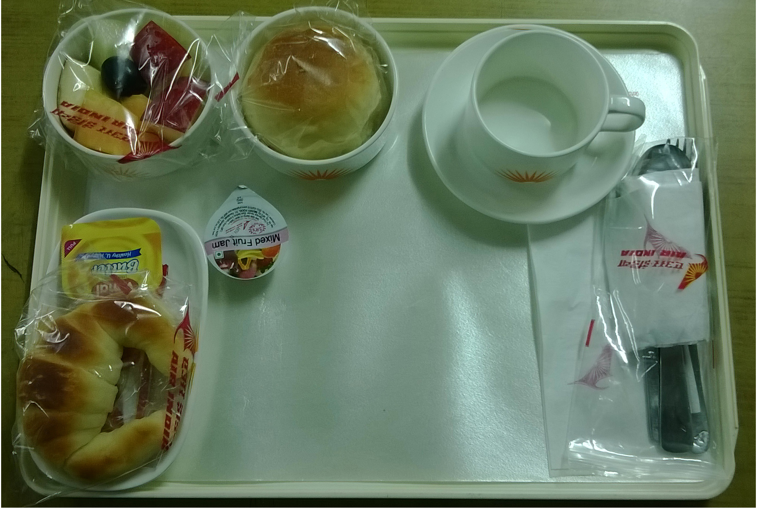 ← J/Class B/Fast

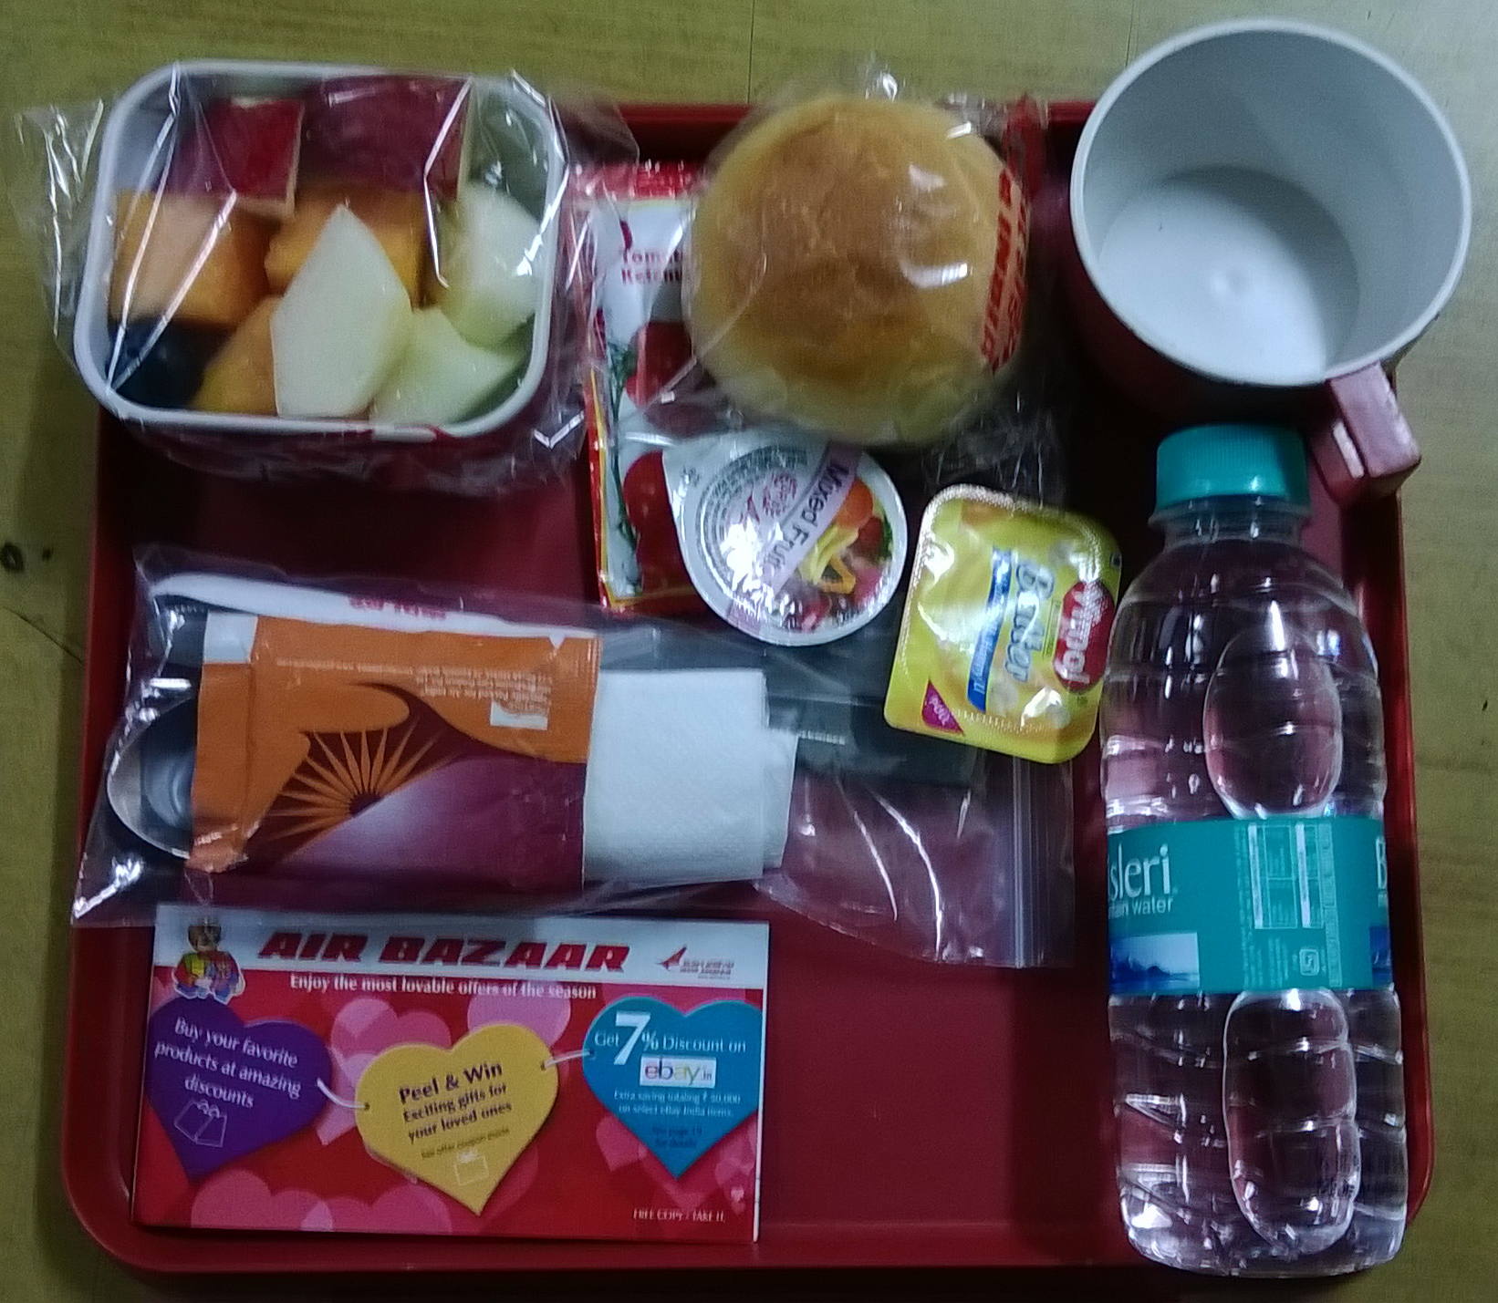← Economy Class B/Fast

- One Lunch / one Dinner set up : means
- 01 Tray
- 01 Teacup
- 01 Cutlery set consisting of 01 teaspoon, 01 knife, 01 fork, 01 dessert spoon, 01 paper napkin, 01 toothpick, 01 sugar sachet, 01 milk sachet, 01 salt pepper sachet, 01 caterer’s card and 01 freshener
- 02 Salad Bowls (for Salad and sweet dish)
- 01 Water Bottle
- 01 Bread Roll
- 01 Butter tub
- 01 Shopping card

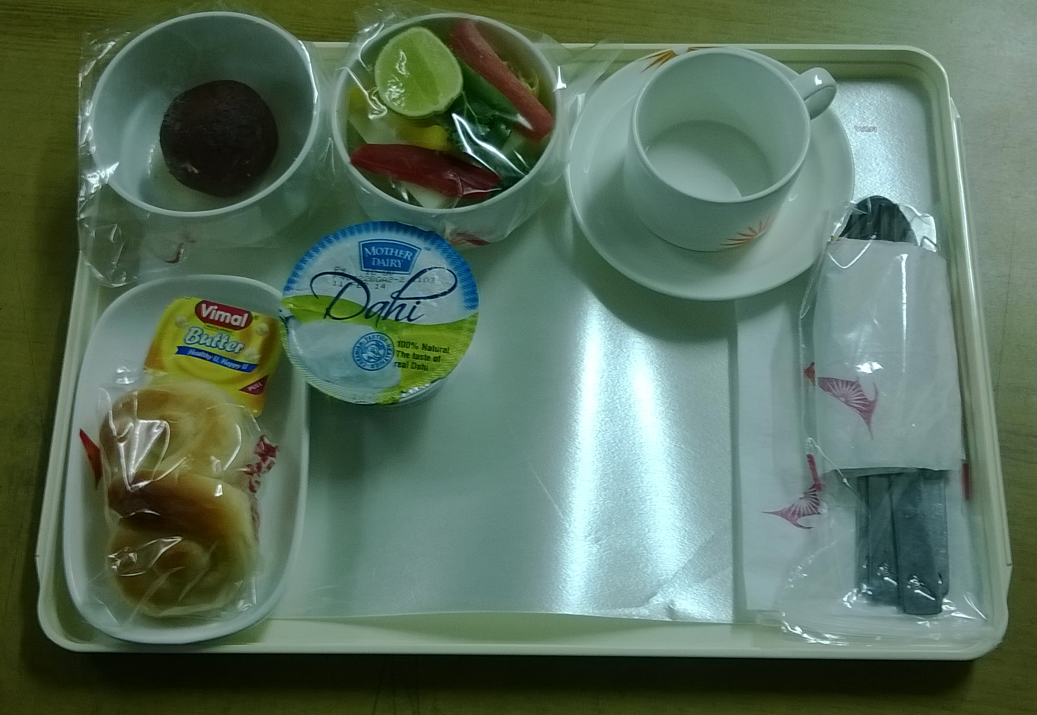 ← J/Class Lunch/Dinner

Contd…5/-
Page: 5
Annexure:III
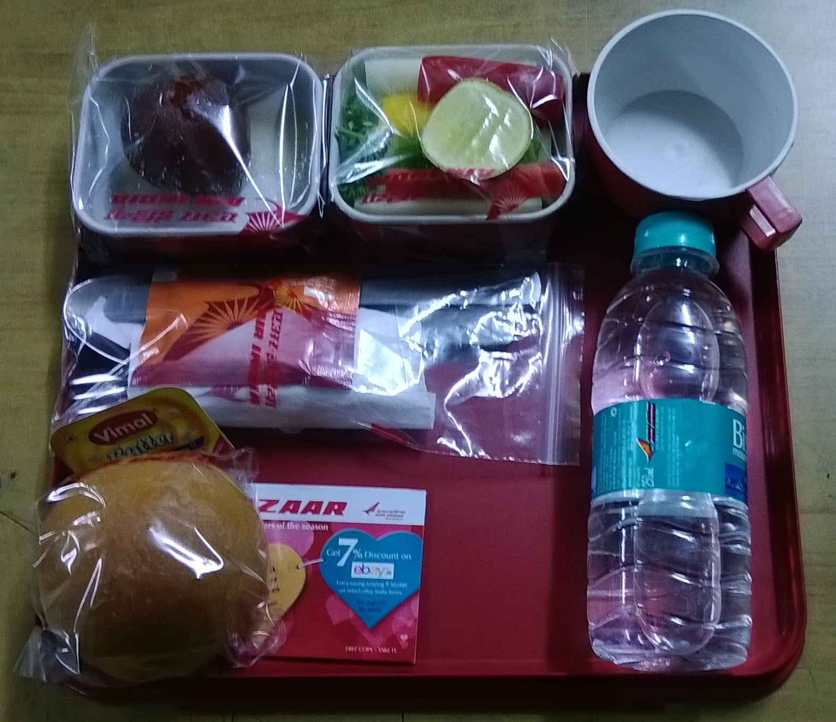← Economy Class Lunch/Dinner

- One High Tea set up : means
- 01 Tray
- 01 Teacup
- 01 Cutlery set consisting of 01 teaspoon, 01 knife, 01 fork, 01 dessert spoon, 01 paper napkin, 01 toothpick, 01 sugar sachet, 01 milk sachet, 01 salt pepper sachet, 01 caterer’s card and 01 freshener
- 01 Salad Bowls (sweet dish)
- 01 Water Bottle
- 01 Sandwich duly cello wrapped
- 01 Tomato Sauce
- 01 Shopping card

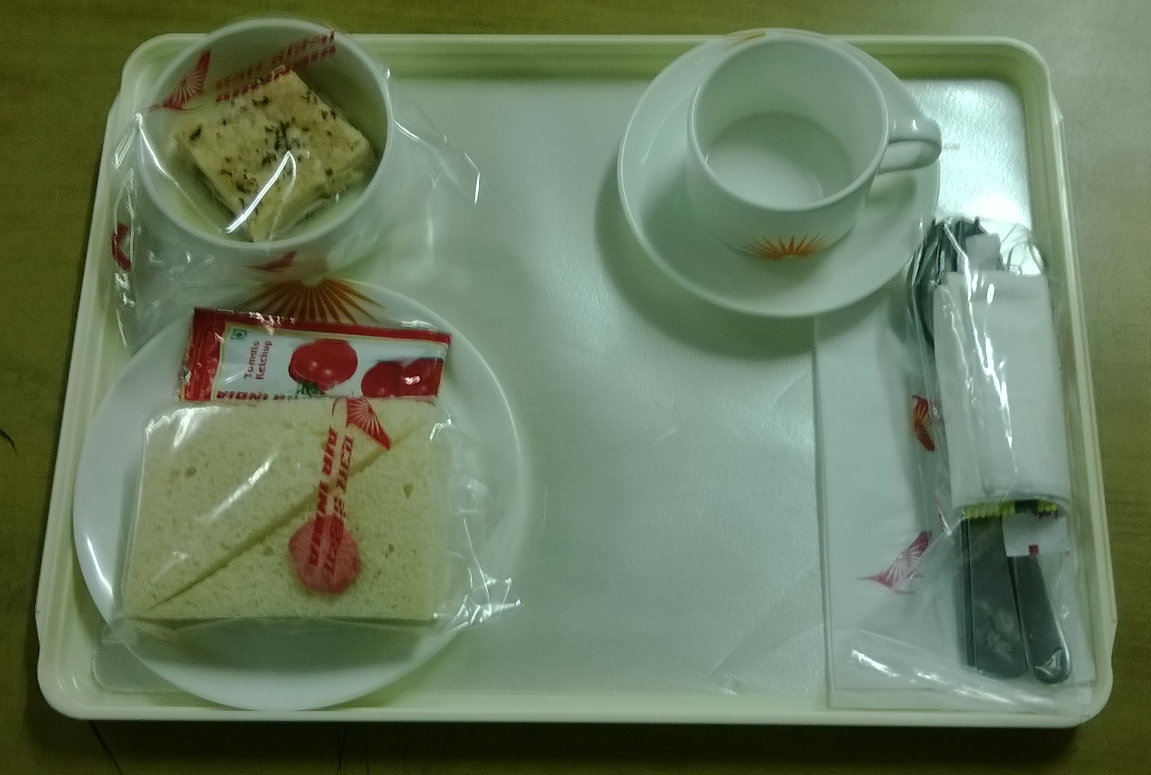← J/Class High Tea

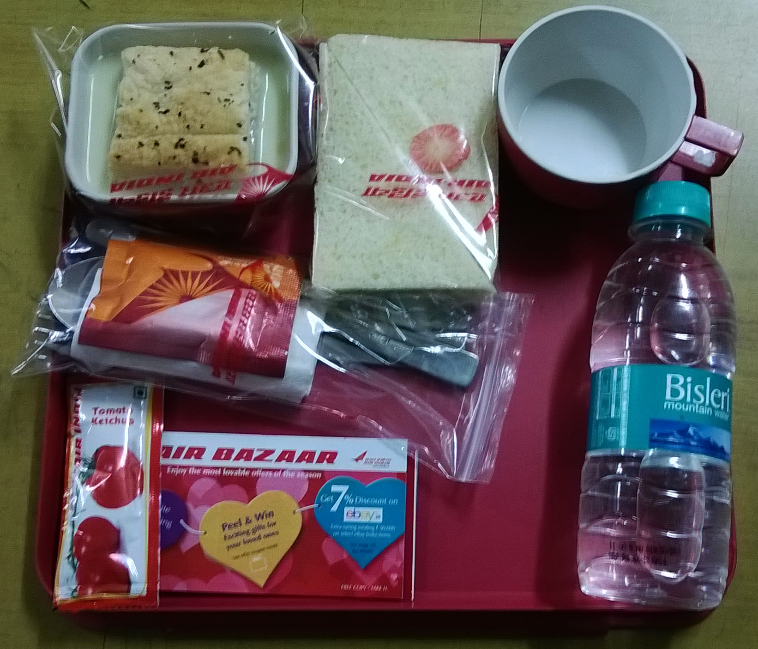← Economy Class High Tea

- In addition to the above economy class presetting, there will be J/Class preset trays also for the passengers depending upon the type of aircraft.
Contd…6/-

Page: 6
Annexure:III
- No of Equipments on a Flight :-
Typically on an A321 aircraft with 20 J -Class, 152- Economy Class seats and 8 Crew members, following will be the approximate number of equipments :

Equipments | Single sector uplift on full load | Double sector uplift on full load,
Minor Equipments | 20 J/Class tray setups,single sector crew meals as per menu | 20 x 2= 40 J/Class tray setups (plus double sector crew meals) as per menu
 | 152 economy tray setups as per above as per menu | 152 x 2=304 economy tray setups as per above as per menu
 | Dry Store items including water bottle cases, tetra pack juices, teabags etc. - all packed in bulk in bags and in drawers | Dry Store items including water bottle cases, tetra pack juices, teabags etc. - all packed in bulk in bags and in drawers
Major Equipments | 6-7 Meal Trolleys, 5 oven Cages, 14 SS service equipment items | 13 Meal Trolleys, 6 oven Cages, 14 SS service equipment items
Note:
i | All minor equipments are put in major equipments (meal trolleys or half trolleys) as per the galley-loading plan for the aircraft.
ii | All major equipments that is 13 meal trolleys, 6 oven cages and SS items will be loaded in the hi-lift for loading on to the aircraft.

- Flow chart of the activities involved in Inflight Catering Services at Aircraft and in the unit :
Loading/Offloading on / from flights (Aircrafts) - Tarmac activity (a)

Offloading of soiled equipment in the Dish Washing Area (b)

Equipment
Dish Wash
&
Stacking (c)
Log

Preparation of equipment including cutlery packing and glass (d)

Presetting of food -TrayAssembly
(e)
Log

Production
&
Meal
Packing
Preloading Chilling (f)

Preloading flight Assembly, Checking
&
Security Check (h)
Airline Stores

Bond (g)
Chilling of Meals

Loading in the hilift (i)

To the Aircraft (a)

- Meaning of Activities involved :

- Loading/Offloading on / from flights/aircrafts – Tarmac activities
- Means loading / offloading of meal trolleys and other equipment as described above, the hi-lift is released from the unit for loading on the flights/aircrafts at the designated aircraft parking bay which is informed by the airline staff prior to releasing of the hi-lift from the unit. As per present airline norms the hi-lift has to be at the tarmac 1½ hour prior to the departure of the flight.
- On the arrival of the aircraft the hi-lift is aligned first at the front door and then, after loading and offloading of catering equipment from front galley, the hi-lift is aligned at the rear door for loading offloading from the rear galley. Aircraft doors are opened/closed only by the airline staff and not by caterers’ staff.
- In the aircraft the fresh equipment and the meals are loaded at the specified locations after offloading of the soiled equipment in to the hi-lift. The galley tabletops are cleaned by the caterers’ staff. After handing over of meals to the cabin crew the hilift is removed from the aircraft and parked at the designated area on the tarmac. No equipment is washed in the hi-lift.
- There are instances where the off loadings are exchanged with other caterers and unused dry store items are handed over to Air India Catering section. In the event of exchange of equipment with other caterer, the hi-lifts of both the caterers are positioned back to back and the equipment is exchanged.
- Samples of the meals are shown to Air India catering officers before loading on the aircraft.
- After the aircraft move out the delivery challan is got signed from the AI Catering Supervisor and Catering Officer.
- After all the above activities, the hi-lift is brought back to the unit and aligned at the offloading platform at the unit.

- Offloading of soiled equipment in the Dish Washing Area in the unit
- Immediate on arrival of the hi-lift, entire soiled equipment is offloaded into the sorting area and major items’ inventory is taken.
- Security checks the items received and takes major inventory.
Contd…7/-
Page: 7
Annexure:III
- Equipment Dish Washing & Stacking in the unit
- The soiled equipment is sorted out and segregated in different sinks and are washed thoroughly either through three-sink method or through dish washing machine. The existing flight type dish washing machine is not fully automatic.
- The garbage generated on the trays like soiled/dirty paper napkins, wrappers, foil dishes/covers etc is thrown in the dustbins/garbage bins.
- Garbage disposal is third parties responsibility.
- Retrievable dry store items like water bottles, soft drinks etc are handed over to airline stores.
- All major equipment are also washed thoroughly and dried/wiped. All stickers etc are also removed.
- The washed equipment is dried and wiped immediately after washing and stacked in baskets/racks. These items are ready to be given to respective kitchens for dishing out salads, sweets etc. Other items like cutlery etc are handed over to various preparation cells.
- All the activities are logged by the supervisor – the temperatures in the dishwashing machine, inventories etc.
- Typically, a single sector flight may have a following equipment to wash:
  - Meal Trolleys: 6
  - Half Trolleys: 4
  - Oven Cages: 6
  - SS Service equipment: 14
  - Drawers: 10
  - Large Trays: 34
  - J/Class Porcelain equipment: 180 pcs.
  - Glassware: 60 nos.
  - Small Trays: 150 nos.
  - Economy Class melamine equipment: 450 pcs.
  - SS Cutlery: 540 pcs

- Preparation of equipment including cutlery packing and glass polishing
- All the glasses are washed, wiped/polished (Spotless) and then wrapped in the paper.
- Washed cutlery items are wiped and packed in polythene cutlery bags as per point (iii) below. Cutlery bags and other disposables are provided by the airlines. The composition of a cutlery set is decided by the airline.
- 01 Cutlery set consists of 01 teaspoon/plastic stirrer, 01 knife, 01 fork, 01 dessert spoon, 01 paper napkin, 01 toothpick, 01 sugar sachet, 01 milk sachet, 01 salt pepper sachet, 01 caterer’s card and 01 freshener.
- All the cutlery sets are kept and given to the presetting staff handling various flights.
- Other equipment like salad bowls etc are handed over to respective kitchens.

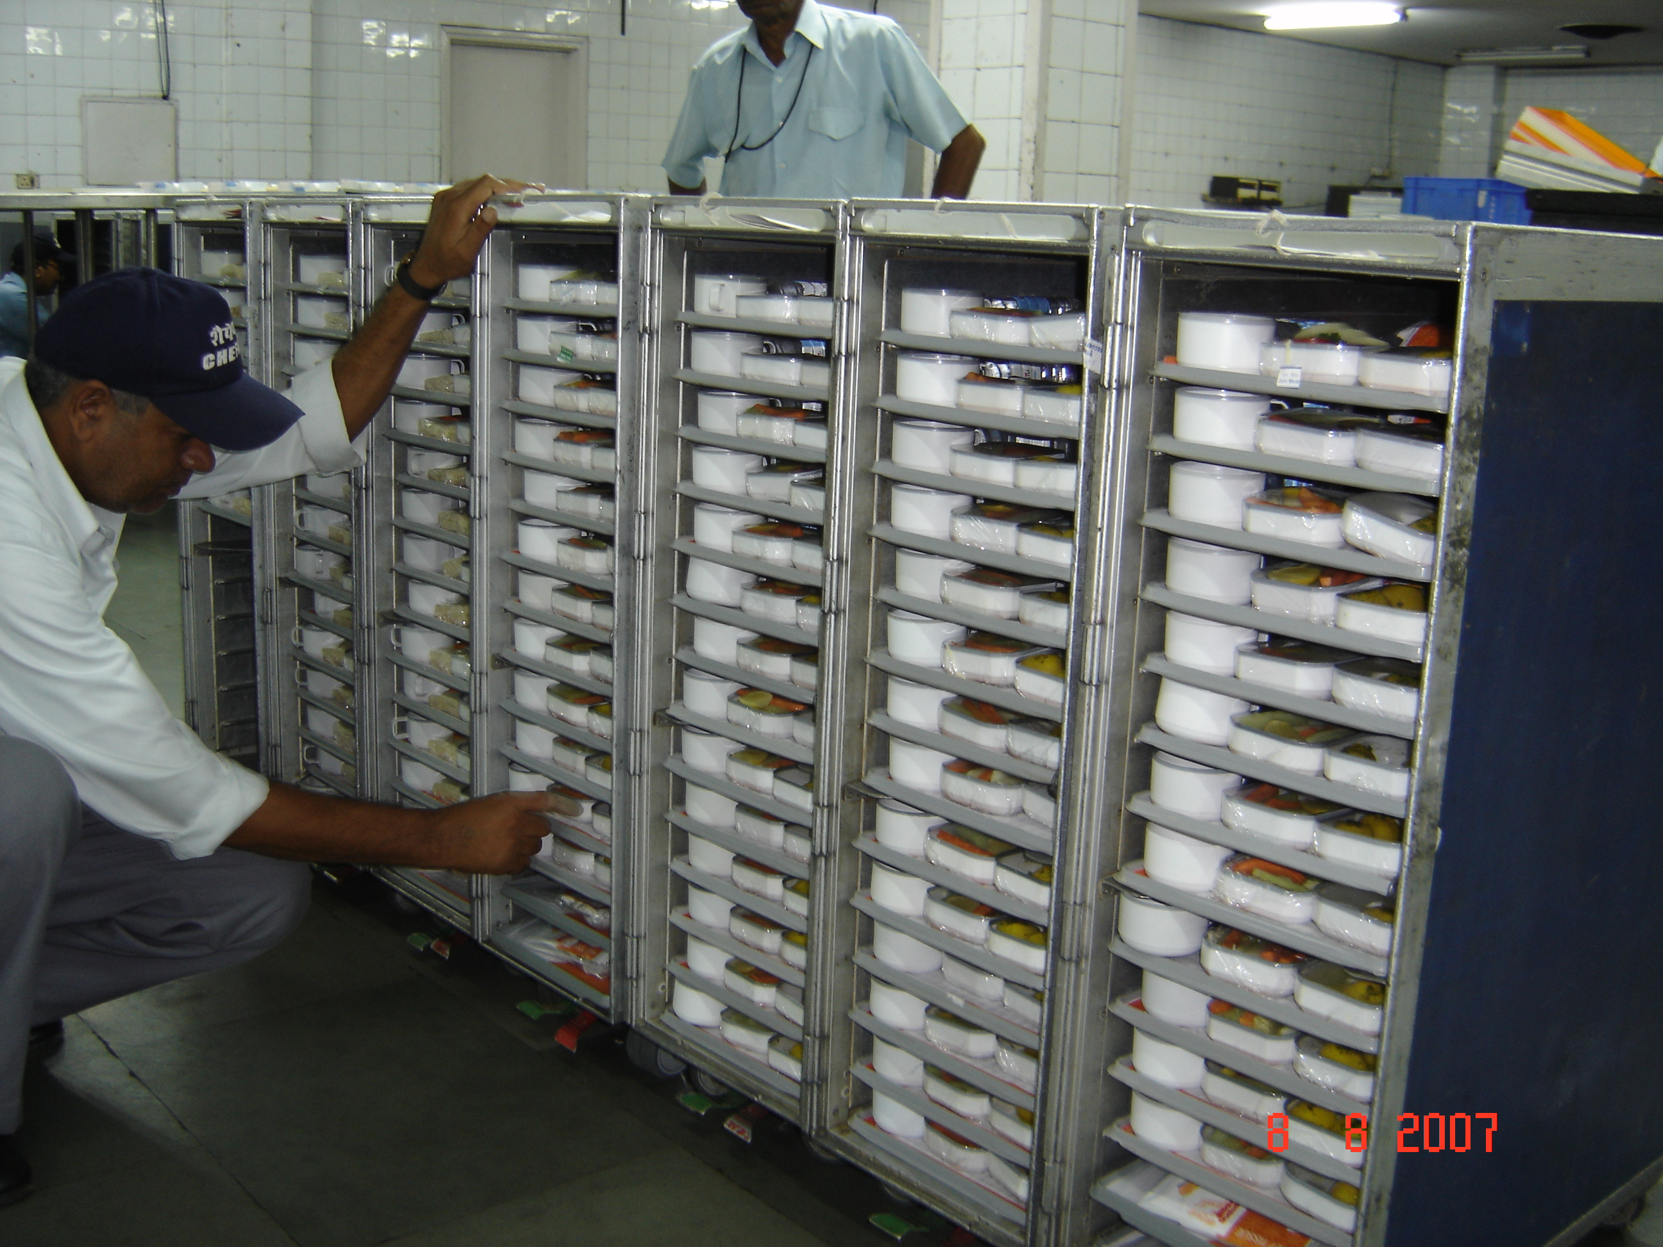←
Contd…8/-
Page:8
Annexure:III
- Presetting of food - Tray Assembly in the unit : means
  - The activity of placing various food items on a tray is called presetting and the entire activity is called Tray assembly.
  - Air India Catering-section informs the passenger load and any changes in the uplift and type of aircraft.
  - As per the load given by the airline, type of uplift and the laid down menu of the day as given by the airlines from time to time, a Kitchen Order Ticket (KOT) is plac
  - The flight supervisor makes the preset list, tags for meal trolleys and for oven cages as per passenger load and galley loading plan for that particular aircraft.
  - The staff allocated for presetting of trays for the flights presets the trays for J/Class, Economy Class, special diets, Crew as per the flight.
  - After completion of presetting, the trays are put in the meals trolleys as per the tags for the meal trolleys given by the supervisor.
  - The trays are not kept lying either on the table or on the conveyor. These should immediately be put in the trolleys.
  - As per the oven cage tags, the supervisor fills the ovens in the kitchen as per the uplift/menu of the flight in consultation with the Chef on duty.
  - These duly filled oven cages are also kept in the cold room along with the meal trolleys of the flight.

← Economy Class meals are being checked.

- Preloading Chilling : means
Completed flight – J/c Tray setups, Economy Tray setups, Crew Tray setups and special diets – all in meal trolleys as per the flight trolley tags given by the supervisor are immediately put in the holding area (a cold room meant for chilling the meals). Under no circumstances the trolleys are kept out side.

- Airline Stores / Bond Stores :
Majority of consumables and non-consumable equipment are provided by the airlines. If the items are locally procured by the airlines then the airline’s local stores directly issue these. If the items are imported then these items are issued after completing custom bond formalities. The items are issued on weekly basis but in case of non-availability of certain items on the weekly stores day, these items have to be issued on any other day. Staff along with supervisor has to be sent to Catering-Stores to get the items issued.
- Dry Stores Packing:
As per the directions from the airlines the dry store items are packed as per the flight schedule. These items include teabags, coffee, sugar sachets, milk sachets, salt-pepper sachets, tooth-picks, paper hand towels, paper napkins, toilet rolls, garbage bags etc.
Contd…9/-

Page: 9
Annexure:III
- Issuance of items to flight presetting :
All consumable are issued to the staff that would be presetting the trays or staff that would be making cutlery sets etc.
- Supervision ;
HCIL / Chefair staff looks after the supervisory part of this activity.

    - Preloading flight Assembly, Checking & Security Check
Before the items are loaded in the hilift, all the ready flight equipment is taken out from the cold room/s are assembled at one place. The dry stores including bulk water bottles, juices, soft drinks, glasses (glass and disposable paper), milk packets etc. are also put in the respective places in the meals trolleys. The completed flight items are checked by the supervisor and then it is handed to Chefair and airlines security who checks the flight and seal all the items either by metal, plastic or paper seal.

    - Loading in the hi- lift
After the security check of the flight and checking from the airlines whether the flight is on time, the flight equipment is loaded in the hilift as per the system and is secured through a belt. The supervisor does a final checking and then the hilift is released for the airport. (back to a)

    - Following are some instant changes:
- There are situations where the uplift may change after presetting is complete. In these cases the tray setups have to be changed and ovens refilled as per the new uplift. This may happen even at the last minute.
- The load may increase/decrease at the last minute.
- The type of aircraft may change at the last minute, which may necessitate re-organizing flight as per the new aircraft.
- Change of aircraft at the tarmac – There may be instances where catering equipment may have to change to other aircraft due to snag etc., even after loading on the first aircraft.

Service Provider’s Role :
i) As described in the flow chart above, the service provider has to perform all the activities in totality – from washing of equipment to presetting of trays to entire tarmac activities.
- The service provider will provide sufficient manpower including supervisors and managers required to handle/manage the above activities on round-the-clock basis as per the requirement in consultation with Incharge - Flight Operations, Chefair-Delhi.
        - Sufficient manpower will be provided to bring stores items including consumables and non-consumables from Catering-Stores.
(iv) Electricity and Water will be provided by HCIL/Chefair.
(v) All cleaning material including soaps, rinse, cleaning agents etc. of branded quality meant for dishwashing machine and wiping material will be provided by the service provider.
(vi) Major machines like dish washing machines, cutlery / glass washing machines, sinks etc will be provided by HCIL/Chefair. The service provider will have to keep the dishwashing and other machines clean and maintained at all times. Damages to any of the equipment will be the responsibility of the service provider and the repair cost will be debited to him on actuals.
Contd…..10/-

Page: 10
Annexure:III

Compliance of Food Safety Norms/Rules
  - Food safety and hygiene are the essence of any food industry including flight catering. The service provider should be well versed with the food safety norms.
( needs to be explained )
b) The service provider should be able to provide services according to food safety and HACCP guidelines. .( needs to be explained )
c) The emphasis will be on the cover all cleanliness of the area as well as the personal hygiene of the staff deployed.
d) The staff uniform given by Service Provider should also consist of disposable gloves, masks and caps.
e) The staff uniform should be clean at all times.
d) On time performance is a major requirement of flight catering which must be kept in mind at all times.
- The supervisors should be able to brief the staff on continuous basis in regard to their duties.

11. Other responsibilities of the Service Provider ;
        - The service provider will obtain at its own costs, security clearance and police verification for its entire staff.
        - The service provider should arrange for BCAS passes for its staff on its own and its own cost.
iii) The service provider will allow Hotel Corporation of India and airport security agencies to search its staff before and after entering/leaving Hotel/Flight Catering premises and airport.
- The service provider will provide proper uniforms and Identity cards / badges to its staff employed by it for providing the aforesaid services and ensure that the staff is always in proper, neat and clean uniform.
- HCIL will not be responsible for contravention of any Government rules and regulations by any of service provider’s staff and it shall indemnify HCI for the same.
- The service provider shall ensure the quality of work performed by its staff and in case of any complaint against a particular person; the service provider shall have to replace such staff. In case of non-compliance of this condition, HCI shall have right to refuse entry of any such staff.
- The service provider will ensure that no staff is under the influence of any addiction/alcohol while on duty.
- The service provider will ensure that all security regulations of HCIL, BCAS, DIAL and/or any other agency associated with airport security is strictly adhered to and complied with.
- Staff transports will be the service provider’s responsibility.
- Service provider will provide medical facilities to its employees.
- The reporting pattern of supervisors/staff will be informed at the time of start of the contract.
- Prompt, punctual, efficient, safe, courtesy and quality are the essence of this service.
- The service provider will provide a list of all staff engaged with the contract.
- The service provider will provide related telephone numbers to HCIL officials.
- The service provider will keep attendance records of all the staff duly signed by the official/s authorized by CFCD.
- The service provider shall be solely and wholly responsible to provide services as outlined above, under any circumstances, without offering any excuse, on religious or other grounds such as state of industrial relations in the establishment, etc.
Contd….11/-
Page :11
Annexure:III
- The service provider shall make every endeavor to fulfill its commitments to the entire satisfaction of HCI.
- The total cost of the items will be deducted from the bills if any item belonging to HCI/Lounge is found broken due to negligence of the service provider’s staff. In this regard, the decision of HCI will be final.
- The service provider will meet all statutory requirements including registration under ESI/PF Acts, etc. in terms of personnel as per Government guidelines as applicable from time to time & other matters and will solely be responsible for its acts.

12. Penalties
- The penalties for non-conformity to the scope of service may be levied up to a maximum of 5% of the total value of the contract.
- The service provider will keep Registers / Log books / Challan books for getting the signatures of the authorized officials of both the Units of HCI on daily basis, for completion of jobs which will further be submitted along with the bills and will form the basis for the payment.
- In case lapses in the services are reflected in the Registers / Log books / Challan books, same will be discussed between the authorized representative of the service provider and the HCI official before onward submission for billing, which will be binding on the service provider.

13. Other Information
- The service provider will indemnify the HCI (including legal expenses and consequential loss) for any loss including third party claim on HCI due to any reason or damage to HCI or equipment resulting in inter alia from the service provider’s negligence, service provider’s staff or equipment.
- For the above liability purposes, the service provider shall maintain an adequate insurance coverage to be mutually agreed upon, with a reputed insurance company.
- The billing cycle will be one month.
- The service provider will meet all statutory requirements in terms of personnel & other matters and will solely be responsible for its acts.

**************

Hotel Corporation of India Ltd.,
IGI Airport, Terminal 2, New Delhi-110037.

ANNEXURE –IV

PERFORMA FOR C E R T I F I C A T E OF UNCONDITIONAL ACCEPTANCE OF TERMS & CONDITIONS OF THE TENDER (TO BE SUBMITTED WITH TECHNICAL BID- PART A PREFERABLY ON TENDERER’S LETTER HEAD)

To,

The Dy. Manager – Purchase,
Corporate Purchase Section,
Hotel Corporation of India Ltd,
Centaur Hotel,
IGI Airport-II, New Delhi -110037

Dated:18.11.2014

Sir,

Sub: C E R T I F I C A T E OF UNCONDITIONAL ACCEPTANCE OF TERMS & CONDITIONS, SPECIFICATIONS OF THE TENDER

Public Tender No. DEL/17/2014-15 , Dated: 18.9.2014 , Due Date ; 18.11.2014

Sub: Flight Operations Services including Tarmac activities at Chefair Flight Catering, New Delhi.

It is certified that we have studied and understood and hereby agree for the terms and conditions and specifications of the subject Tender issued by “HCIL”.

Signature of Authorised Signatory………………

Company Seal……………………

***********

Annexure- V
Hotel Corporation of India Ltd.,
IGI Airport, Terminal 2, New Delhi-110037.

Technical Bid Form – Part A

Public Tender No. DEL/17/2014-15 , Dated: 18.9.2014 , Due Date ; 18.11.2014

Sub: Flight Operations Services including Tarmac activities at Chefair Flight Catering, New Delhi.

1 | Name of the Bidder / Co.
3 | Status of the Bidder i.e. Whether applying as a Principal service provider. Documentary proof may be enclosed.
4 | Whether documentary proof for status enclosed. | Yes / No
5 | Complete Address of the bidder/Co with Telephone No. / Mobile No./ Fax No.  /email ID
6 | Name of Contact Person & mobile.
7. | Whether proof of address- electricity bill / water bill / house tax receipt / rent agreement / MOU etc enclosed. (Must) | Yes / No
8. | Whether EMD of Rs. 50,000.00 enclosed. Original DD/Cash receipt to be enclosed. (Must) | Yes/No | DD/Cash Receipt No. ……  Date………………….
9 | Whether EMD exemption sought | Yes / No
10 | In case, yes to 9 above, whether the bidder is regd with NSIC under its single point regn. programme. | Yes / No
11 | In case, yes to 10 above, whether self attested copy of valid NSIC Regn. Certificate enclosed. | Yes / No
12 | Whether having 3 years experience of Inflight Services as Principle service provider (Must). A copy of contracts together with satisfactory performance certificate from user to be enclosed in support of experience. | Yes / No
13 | Whether copies of contracts enclosed. (Must) | Yes / No
14 | Whether copies of performance certificate issued by the user enclosed. (Must ). | Yes / No
15 | Whether list of clients attached. (Must ) | Yes / No
16 | Whether having ESI registration.  A self attested copy to be enclosed. (Must) | Yes / No | ESI Regn No…….
17 | Whether having PF registration.  A self attested copy to be enclosed. (Must) | Yes / No | PF Regn. No……
18 | Whether having PAN/GIR regn No.  A self attested copy to be enclosed. (Must) | Yes/No | Regn No……,Date….

Annexure- V

19 | Whether having TIN No. A self attested copy to be enclosed. Optional. | Yes/No | Tin No……,Date….
20 | Whether having Service Tax Regn.  A self attested copy to be enclosed (Must) | Yes/No | Regn No……,Date….
21 | Whether having an average turnover of Rs. 62.0 Lacs per year for last 03 Fin yrs i.e. 2011-12.12-13,13-14. | Yes/ No. | 2011-12. Rs……. lacs  2012-13. Rs……..lacs  2013-14. Rs……..lacs
22 | Whether self attested copy(s) of Income Tax Returns for last 03 Fin years-2011-12,12-13,13-14 enclosed. | Yes/No | 2011-12…..Yes/No  2012-13…. Yes/No  2013-14…..Yes/No
23 | Whether self attested copy(s) of balance sheet for last 03 Fin years-2011-12.12-13,13-14 enclosed in support of Turn over. | Yes/No | 2011-12…..Yes/No  2012-13…. Yes/No  2013-14…. Yes/No
24 | Whether self attested copy(s) of Profit & Loss a/c for last 03 Fin years - 2011-12.12-13,13-14 enclosed in support of Turn over. | Yes/No | 2011-12…..Yes/No  2012-13…. Yes/No  2013-14…. Yes/No
25 | In case tenderer is not making balance sheet or exempted to do so in that case, he / she  should enclose copy of 3 yrs bank statement together with certificate of C.A stating 3 yrs  turnover.
26 | Whether self attested copy(s) of bank statement showing year wise income for 3 yrs 2011-12,12-13,13-14 enclosed in support of turn over. Applicable when B/l Sheet,P/L a/c & ITRs are not applicable. | Yes/No | 2011-12. Rs……. lacs  2012-13. Rs……..lacs  2013-14. Rs……..lacs
27 | Whether self attested copy(s) of certificate of C.A , stating year wise income for 3 yrs 2011-12,12-13,13-14 enclosed in support of turn over. Applicable when B/l Sheet,P/L a/c & ITRs are not applicable. | Yes/No | 2011-12. Rs……. lacs  2012-13. Rs……..lacs  2013-14. Rs……..lacs
28 | Whether Certificate for unconditional acceptance of terms and conditions of the tender enclosed.(Must). | Yes/No
29 | Are you already doing business with HCI or any of HCI Units? If so, in what name? | Yes/No | M/S……………..
30 | Has your company been Black Listed by any agency of the Airport or elsewhere. If yes, please give details. | Yes / No | If yes, details. ………………
31 | Any other information which you feel would qualify you to be enlisted in our list of suppliers.

Undertakings : To be agreed & signed by the tenderer(S) :

- It is confirmed that we have the capability & capacity to provide services for which we have quoted rates in the Financial Bid Form – Part –B as per terms & conditions of the tender.

Annexure- V
- It is also confirmed that we have carefully gone through and have understood scope of work and hereby agree to abide by all the Terms & Conditions governing the tender.

- It is also confirmed that I am authorized to sign the tender documents and the information given is true and correct to the best of my knowledge and belief and nothing material is concealed.

- It is also confirm that the documents attached in support of the details filled in the Technical Bid Part –A above are correct.

- It is also confirmed that the ratyes quoted by us in the Financial bid are valid for 120 days for consideration of HCIL.

Signature of authorized signatory : _______________________________

Name & Designation: _____________________

Co. Name & Seal: _________________________

Date: ___________

Place: __________

***************

Hotel Corporation of India Ltd.,
IGI Airport, Terminal 2, New Delhi‐110037.
Annexure- VI

PRICE BID FORM – PART B

Public Tender No. DEL/17/2014-15 , Dated: 18.9.2014 , Due Date ; 18.11.2014

Sub: Flight Operations Services including Tarmac activities at Chefair Flight Catering, New Delhi.

1. | Name of the Bidder / Co.
2 | Complete Address of the bidder/Co.
3 | Telephone No. / Mobile No./ Fax No./ email ID
4 | Name of Contact Person & mobile.
5.0 | Rates Rs. ……Per Flight for providing Flight Operations Services at Chefair Flight  Catering, New Delhi as per work scope and as per terms of the Tender.
5.1 | Rates Rs. Per Flight for Single Sector Flight |  | Rs…………………..per Flight.
5.2 | Rates Rs. Per Flight for Double Sector Flight |  | Rs…………………..per Flight.
5.3 | L-1 CRITERIA : | L-1 Bidder shall be decided based on the L-1 average rates quoted at 5.1 and 5.2 above that is  L-1 Rate = ( Rate Rs.at 5.1 + Rate Rs. at 5.2 )  2

- Inclusion and Exclusions, Govt. taxes and levies applicable to quoted rates.

a) Inclusions:
The rates quoted in the tender shall be inclusive of Govt Taxes and levies, cost of manpower, cost of raw material such as cleaning agents and detergents, Airport Entry permit fee, Dial training cost, Provision for Name Badges & Uniform including High visibility jackets, ID Cards and all statutory payments like ESI / PF etc.

b) Exclusions:
i) The Service Tax (including education cess) and DIAL charges / Gross Turn over Tax (GTO) of DIAL/GMR, if applicable on these services, shall be excluded. Service Tax and DIAL charges / GTO of DIAL/GMR, if applicable, and if paid by the party, would be reimbursed on submission of receipt as proof for payment together with monthly bills.
- Any additional charges / levies , if imposed by DIAL during the currency of the contract, same would be re-imbursed separately by HCIL on production of receipt as proof of payment.

Contd..2/-

Page:2

Annexure- VI

7. Rates quoted in the Tender shall be valid for 120 days from the date of opening
of technical bids for consideration of HCIL.

- It is confirmed that I am authorized to sign tender documents.

Signature of authorized signatory : _______________________________

Name & Designation: _____________________

Co. Name & Seal: _________________________

Date: ___________

Place: __________

***************

